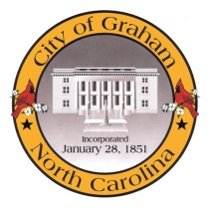
2017-2018 Façade Grant Program Overview
The façade grant program provides matching funds for exterior improvements to historic non-residential structures. It is designed to provide incentive funds to property owners in the Historic District to increase rehabilitation activity. It promotes the beautification of the Historic District and its importance to the history of Graham and its residents. The funding only applies to improvements that are consistent with the historic district. Applications for funding are approved by the Historic District Commission. Examples of improvements include:
What is a Façade?
A façade is one side of a building regardless of the number of stories. Each store front of a building can be considered a façade. The rear of a building may also be considered for a façade grant with priority given to the front of the building.

  - Removing of false fronts and metal canopies
  - Safe cleaning of brick and stone fronts
  - Sign replacements
  - Canvas awning installation
  - Window and door repairs or replacements
  - Repainting
  - Structural repair to exterior
  - Historic reconstructions
  - Store front reconstruction
  - Tuck point mortar joints
  - Stain brick to match existing
  - Roof vents on store face
  - Exterior lighting
  - Relocate electrical wiring

Who is Eligible?
Owners or tenants of non-residential properties in the Courthouse Square Historic District are eligible to apply. Tenants must include a signed letter of permission from the property owner as part of their application.
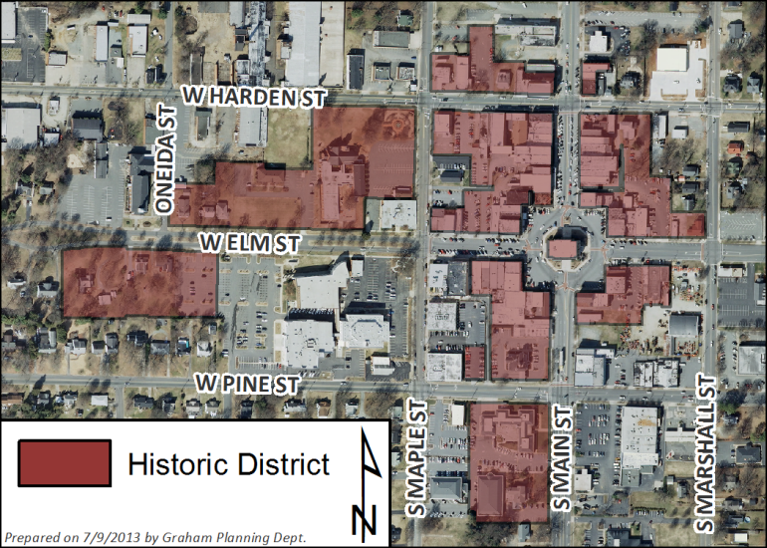
Funding and Renovation Guidelines
This is a cost reimbursement program. Projects are funded on a 50-50 matching basis, with the maximum City contribution being $5,000. The applicant’s match may include funding from other sources. Only one grant per year can be awarded to a property.
This program applies solely to exterior improvements. All proposals must follow the City’s building code requirements. All renovations on buildings over 30 years old must follow the Secretary of the Interior’s Standards for Rehabilitation.
How to Apply
To be considered for funding, a complete application packet must be received by the Planning Department no later than 5:00pm on Monday, September 25, 2017.
A complete application packet includes:
  - A fully completed application form
  - An existing photo of the building or structure
  - Drawings, sketches or pictures showing the proposed renovations
  - At least two itemized cost estimates
Complete application packets should be sent to
Nathan Page at npage@cityofgraham.com
or at 201 S Main St, Graham, NC 27253.
What if my application is approved?
After approval, the applicant has until May 1, 2018 to complete the project. If more time is needed, a written request for an extension with a reasonable explanation must be submitted to the Planning Department.
Applicants will receive reimbursement once the project is completed, it is inspected and approved by the City’s Inspections and Planning Departments, and paid receipts are submitted to the Planning Department. Any renovation work completed prior to an application being approved by the Historic District Commission will not be eligible for reimbursement.
For more information or questions, contact Nathan at npage@cityofgraham.com or 336-570-6705.

2016-2017 Façade Grant Program Application
Property Information | Applicant Information
Street Address: | Name:
Tax Parcel ID#: | Phone Number:
Owner’s Name: | Email:
Use of Building: | Relationship to Property (check one):
Business Name (if applicable): | Property Owner Tenant/Business Owner
Description of Proposed Façade Renovation
Write a succinct description below and attach 1) an existing photo of the building and 2) a drawing, sketch or picture of the proposed renovations, specifically identifying changes and paint color for each detail of the building.
Total Estimated Cost (lowest bid quote): $ Attach at least two itemized cost estimates for proposed work.
Checklist for a Complete Application
I have read the City of Graham Façade Grant Program Overview and fully understand the agreement.
I have met with the City Building Inspector. My project [does / does not ] require a building permit.
I have complied with the Secretary of the Interior’s Standards for rehabilitation. (Building is not over 30 years old )
The owner’s written and signed permission is attached, if applicant is not owner. (Not applicable )
An existing picture of the building and a drawing, sketch and/or picture of the proposed renovation are attached.
At least two itemized project cost estimates are attached.
I understand that the City of Graham Façade Grant Program must be used in the manner described in this application, and the application must be approved by the Graham Historic District Commission prior to commencement of any project. I understand that failure to comply with the approved application may result in a forfeiture of all grant funds. I understand it is the applicant’s responsibility to meet deadlines and request reimbursement on or before May 1, 2018.
Applicant Signature Date

