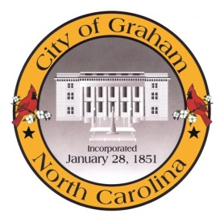

Planning Board

Meeting Agenda
November 15, 2016 at 7:00 PM
Council Chambers, 201 S Main St
Meeting Called to Order, Invocation, and Overview of Board and general meeting rules
1. Approve minutes of the October 18, 2016 meeting
2. New Business
a. Grant Applications
3. Old Business
a. Discussion of Downtown Economic Development Ideas

4. Public comment on non-agenda items
Adjourn
A complete agenda packet is available at www.cityofgraham.com

