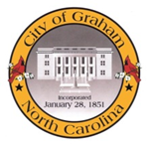

PUBLIC MEETING NOTICE

NOTICE is hereby given that the appointed committee of the North Carolina Commerce Park (NCCP) Organizational Committee will hold a Public Meeting on Thursday, September 10, 2015 at 6:00p.m. at the Mebane Municipal Building, 106 E. Washington Street, Mebane NC 27302.
The purpose of the meeting will be to update property owners in regard to site certification and master planning services to be offered by Samet Corporation. Committee members from the City of Graham, City of Mebane and Alamance County will be in attendance.
All interested persons are invited to attend.

Darcy Sperry
Graham City Clerk

