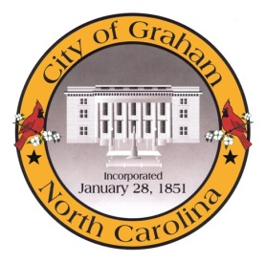

Historic Resources Commission

Meeting Agenda
January 10, 2016 at 6:00pm
Council Chambers, 201 S Main St
- Pledge of Allegiance and opening invocation.
- Approve minutes of the November 8, 2016 meeting.
- Discussion of penalties for the Court Square District.
- Change in request for Façade Grant awards.

A complete agenda packet is available at www.cityofgraham.com

