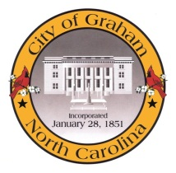
Budget Retreat

Agenda

February 24, 2015, 8:00am

Graham Police Department

216 S. Maple St.

8:00am Meeting called to order by Mayor

8:05am Fellowship with Donuts, Fruit & Coffee

8:15am Police Dept. Tour

9:00am Prefacing the FY 2015-2016 Budget (Frankie Maness)
- FY 2014-2015 Budget Status and Project Updates
- Budget Calendar
- New Challenges and Opportunities

10:00am Discussion of 2016-2020 Capital Improvement Plan

10:30am Roundtable Discussion with Department Heads

11:30am Discussion, Conclusions and Q & A

12:00 noon Adjournment (lunch from Guerrero’s Restaurant will be provided)

