2015 Graham Community Cleanup Day
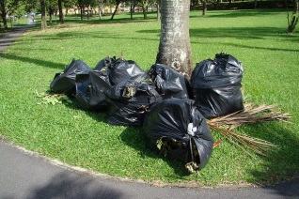

Saturday, May 16 8:00am – 11:00am
Check-In Location: Graham Fire Department
* * * * * *
This community event is open to all families, scout troops, service or church organizations and residents who are dedicated to keeping Graham a beautiful place to live.
Safety vests, trash and recycle bags will be provided.

For additional information, contact
Graham Parks and Recreation Department – 336.513.5510

Sponsored by the Graham Appearance Commission
In the event of rain, the event will be canceled.

