STAFF REPORT
Prepared by Nathan Page, Interim City Planner

Patterson Place (Stillhouse Farms) (CR0502)
Type of Request: Conditional Rezoning
Meeting Dates
Planning Board on March 17, 2015
City Council on April 14, 2015
Contact Information
Mark Richardson 980-318-500
15800 John Delaney Dr, Suite 120
Charlotte NC, 28277
mrichardson@greenwayllc.net

Summary
This is a request to amend the initial Conditional Mixed-Use-Residential (C-MXR) that was approved May 3, 2005. The site remains vacant today. The intention is to redesign the 112 unit townhome section into 80 multi-family dwelling units for seniors. Due to the increased regulations during the interim, the site will now need to comply with our stormwater ordinance.
Location
Cheeks Lane, E Moore Street
GPIN: 8883569808, 8883552739, 8883359916, and 8883367159
Current Zoning
Conditional Mixed Use Residential (C-MXR)
Proposed Zoning
Conditional Mixed Use Residential (C-MXR)
Overlay District
None
Surrounding Zoning
R-18, R-12, B-2 & I-1
Surrounding Land Uses
Single Family Houses, General Businesses, Light Industrial and Undeveloped
Size
approximately 70 acres
Density
3.0 DU/acre
Public Water & Sewer
Water and Sewer will need to be extended by developer
Floodplain
Yes, across portion of property
Staff Recommendation
Approval with conditions
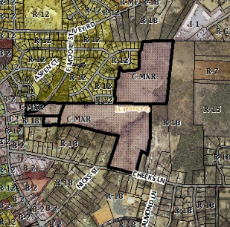
The applicant is proposing to amend the conditional zoning to allow for a different style of construction and rental units for the Cheeks Lane portion of the property. The preliminary site plans, completed by Cline Design on 2/25/2015, as well as building elevations are enclosed to provide additional information regarding site layout and design.
The proposal is for an 80-unit multifamily development consisting of twelve residential buildings, a maintenance building and a community center complex. All buildings are proposed to be one-story tall. The applicant also proposes to provide large areas of open space, as well as a protected corridor for the future Southern Loop.

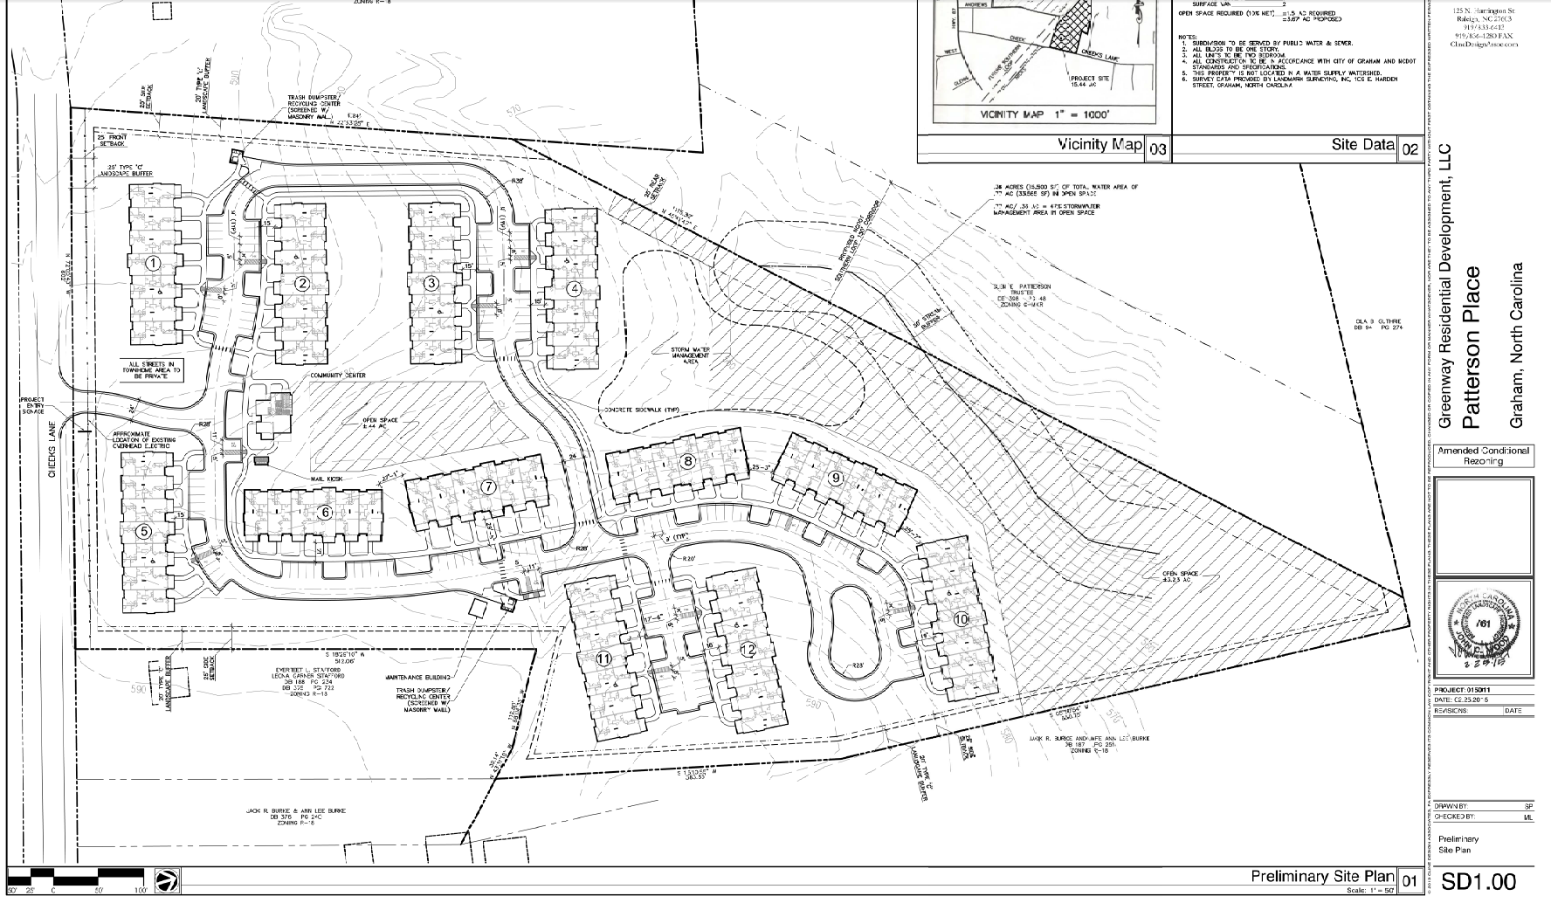

Technical Review Committee
The TRC reviewed the original preliminary site plan and met with the applicant on March 2, 2015. The following TRC comments have not been addressed on the preliminary site plan:
- Cheeks Lane is identified as a priority corridor in our pedestrian plan. Please provide a sidewalk along Cheeks Lane.
- Plan must address how the property is to be served by water and sewer.
- Stream determination points will need to be field verified.

Conformity to the Growth Management Plan (GMP) and Other Adopted Plans
Applicable Goals to Guide Us into the Future
- 6.1.1. Support efforts to protect sensitive natural resources including wetlands, waterways, slopes, floodplains, etc. Steelhouse Branch Creek crosses the property. The proposed development is set back from the creek and floodplain in accordance with the Development Ordinance.
- 6.1.3 Enforce landscaping standards to help beautify and buffer development sites. The proposal includes a type “C” yard buffering all nearby residential properties, as well as a street yard for the portion abutting Cheeks Lane.
- 6.3.1. Encourage the conversion and development of higher density residential development around the downtown and other designated activity areas. This proposal is for a higher density residential development in a Traditional Neighborhood Zone.
Planning District
South
Development Type
Village Center, Traditional Neighborhood Development and
Neighborhood Residential
For single family residential, townhouses, apartments & condominiums, commercial, office/institutional and mixed use
Characteristics include open space; parks included with development; pedestrian-oriented; automobile-oriented; design requirements; sidewalks; street trees; landscaping; buffering/screening; parking provided on-site; height of structures regulated; controlled access; building orientation
Density of 3+ DU/acre or
10,001 to 100,000sf of retail
Infrastructure includes
water, sewer, street connectivity and underground utilities
- 6.3.1. Prohibit residential development that is in close proximity to incompatible uses or provide proper buffering to protect existing uses and new development. The proposed dwelling units are adjacent to Cheeks Lane and undeveloped land and low density residential. The location also identifies a corridor for the future Southern Loop.
Applicable Planning District Policies and Recommendations
- 7.5.4.1.1 Improve the transportation network to allow for east-west corridors in the southern section of Graham, which would alleviate pressures on South Main Street and offer residence alternative transportation routes. The project protects a potential alignment for the proposed Southern Loop.
- 7.5.4.1.6 Encourage residential development that conserves land along rivers, creeks and tributaries to protect environmentally sensitive areas, promote open space preservation and provide a natural buffer for waterways. The proposal includes open space encompassing an identified creek to the northwest of the project.
- 7.5.4.1.8 Encourage neighborhood residential development in remaining undeveloped areas that are adjacent to existing residential developments. Additionally, interconnectivity between neighborhoods should be a priority for new developments. The northern portion of the plan, comprised of single family homes, is to connect to existing road ends. The southern portion of the plan, consisting of multi-family dwelling units, is to be divided from the balance of the property by the Southern Loop, and connect only to Cheeks Lane.

Graham Pedestrian Plan
- Recommends a sidewalk on this section of Cheeks Lane as a high priority project.
Staff Recommendation
Based on the Growth Management Plan 2000-2020 and the City of Graham Development Ordinance, staff recommends approval of the Conditional Rezoning, with the following conditions:
- The project will supply a sidewalk along Cheeks Lane.
- The final site plan must be submitted to and approved by the TRC before a building permit and/or certificate of occupancy will be issued.

The following supports this recommendation:
- The development furthers a number of goals of the Growth Management Plan and is consistent with the Development Toolkit Checklist for Regional Commercial Center.
- The development complies, or will comply upon final site plan approval, with the standards of the Development Ordinance.

