STAFF REPORT
Prepared by Nathan Page, Interim City Planner

Graham Manor (CR1501)
Type of Request: Conditional Rezoning
Meeting Dates
Planning Board on March 17, 2015
City Council on April 14, 2015
Contact Information
James B. Smith, United Developers, Inc.
2939 Breezewood Ave, Ste 201
Fayetteville, NC 28303
910-485-6600; jsmith@dugginssmith.com

Summary
This is a request to rezone the subject property from R-18 to C-R to construct a 56-unit senior rental community. The parcel is currently wooded. One stream crosses the property and there is a 50-foot PNG gas line easement on the front of the property next to Auto Park Dr.
Location
Auto Park Dr and Hanford Rd
GPIN: 8883091817
Current Zoning
Residential (low density) (R-18)
Proposed Zoning
Conditional Residential (C-R)
Overlay District
none
Surrounding Zoning
R-18, R-12, B-2 & I-1
Surrounding Land Uses
Single Family Houses and
General Businesses
Size
18.2 acres
Density
3.1 DU/acre
Public Water & Sewer
Yes, along Auto Park Dr and Hanford Rd
Floodplain
No
Staff Recommendation
Approval, with condition

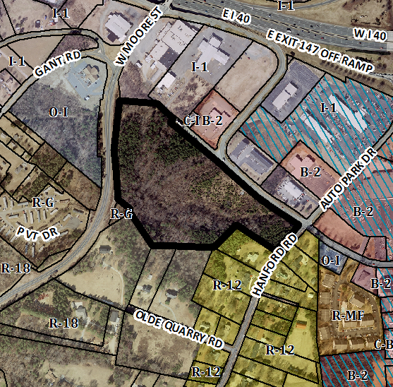
The applicant is proposing to rezone the property to C-R in accordance with the preliminary site plan and building elevations prepared by MDG, dated March 4, 2015. The proposal is for a 56-unit senior rental community consisting of a two-story residential building. Internal to the building are a chapel, library, hair salon, and a game room. The applicant also proposes to construct a gazebo and outdoor seating area, as well as a path which encircles the property. Some additional specifics:
- 50 two-bedroom units and 6 one-bedroom; six will be fully accessible
- 84 parking spaces, including 10 ADA compliant spaces
- Erosion control to meet stormwater requirements
- Thirteen acres of undisturbed natural area

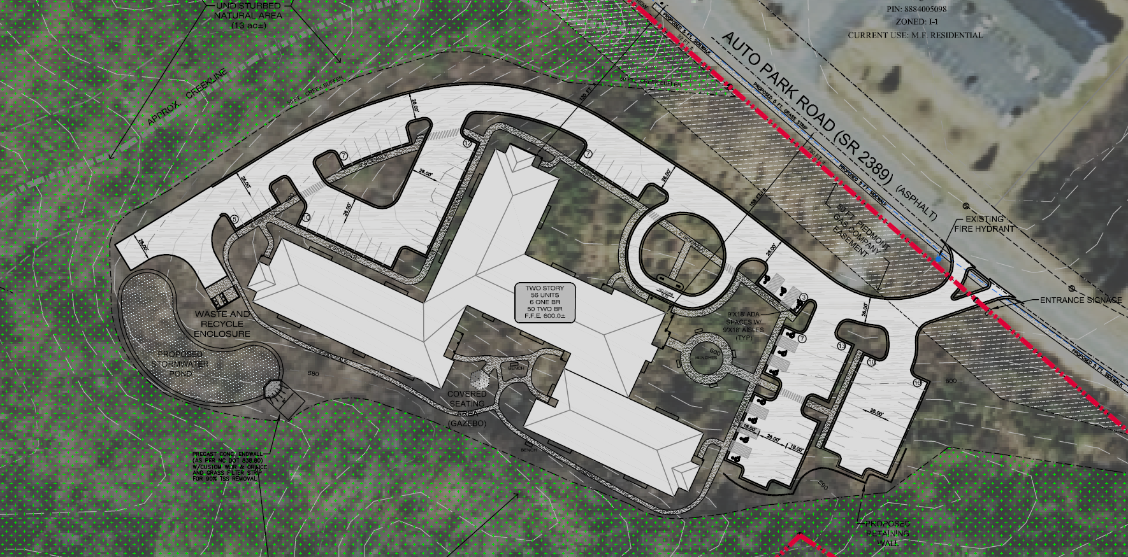

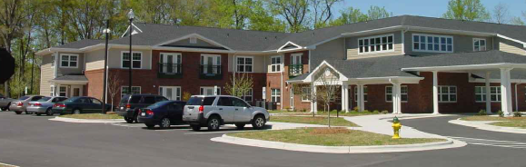
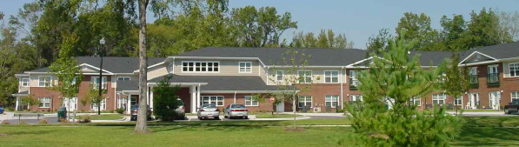

Technical Review Committee
The TRC reviewed the preliminary site plan and met with the applicant on February 2, 2015. The applicant has resubmitted a site plan which will go before TRC for approval after Planning Board meets. Some preliminary TRC comments that may impact the overall development include:
- The riparian buffer for the northern stream is 50 feet from the top of bank; this may impact the location of buildings and parking
- Wetlands must be delineated on site

Conformity to the Growth Management Plan (GMP) and Other Adopted Plans
Applicable Goals to Guide Us into the Future
Planning District
Central
Development Type
Neighborhood Residential adjacent to Highway Commercial
Located near a major thoroughfare
For single family residential
and townhouses
Characteristics include
open space; parks included with development; pedestrian-oriented; automobile-oriented; sidewalks; street trees; landscaping
Density of 3+ DU/acre
Infrastructure includes
water, sewer, street connectivity and underground utilities
- 6.1.1. Support efforts to protect sensitive natural resources including wetlands, waterways, slopes, floodplains, etc. There is one stream and potentially wetlands on this site. The development will be required to abide by riparian buffer requirements.
- 6.1.3. Enforce landscaping standards to help beautify and buffer development sites. The proposal will, upon final TRC approval, adhere to the City’s landscaping requirements.
- 6.3.1. Prohibit residential development that is in close proximity to incompatible uses or provide proper buffering to protect existing uses and new development. The proposal includes a large undisturbed natural area between the development and adjacent single family homes and will itself serve as a transition between existing commercial and industrial developments and single family houses.
- 6.3.7. Encourage the incorporation of open space design within new developments. The proposal includes a walking trail and other common open and undisturbed areas.
Applicable Planning District Policies and Recommendations
- 7.4.4.1.3. Provide a transitional buffer between the proposed commercial and village centers and existing or proposed single-family neighborhoods that would consist of landscaping, multi-family developments and/or townhouse developments. The proposed multifamily development and adjacent undisturbed natural areas would provide a transition between existing single family houses and the commercial and industrial development along S Main St, Auto Park Dr and W Crescent Square Dr.
- 7.4.4.1.7. Encourage residential development that conserves land along rivers, creeks and tributaries to protect environmentally sensitive areas, promote open space preservation, and provide a natural buffer for waterways. The development will include approximately 13 acres of undisturbed natural area adjacent to a creek and will be required to abide by riparian buffer requirements.
- 7.4.4.1.8. Encourage neighborhood residential development in remaining undeveloped areas that are adjacent to existing residential developments. Additionally, interconnectivity between neighborhoods should be a priority for new developments. The proposed multifamily development is on a large undeveloped tract that backs up to existing residential development and is across the street from commercial and light industrial developments. The streams and existing surrounding development make new road connections difficult.
Graham Pedestrian Plan
- Recommends a five-foot sidewalk on Hanford Road and Auto Park Drive as a lower priority, long-term project. The developer has proposed a sidewalk along Hanford Road and a portion of Auto Park Drive.
Staff Recommendation
Based on the Growth Management Plan 2000-2020 and the City of Graham Development Ordinance, staff recommends approval of the Conditional Rezoning, with the following condition(s):
- The final site plan must be submitted to and approved by the TRC before a building permit and/or certificate of occupancy will be issued.
- The size and layout of the stormwater treatment device will be evaluated as part of final site plan review. If these necessitate a shift in the location of buildings or parking, these revisions will maintain the general layout of the site as proposed and will conform to all ordinance requirements for multifamily, or they will be considered major revisions.
The following supports this recommendation:
- The development furthers a number of goals of the Growth Management Plan. While it is not strictly consistent with the Development Toolkit Checklist for Neighborhood Residential because it is multifamily as opposed to townhouses, the proposal is at a similar scale and density to what could be expected of a multifamily development and provides a large forested buffer.
- The development complies, or will comply upon final site plan approval, with the standards of the Development Ordinance.

