STAFF REPORT
Prepared by Nathan Page, Interim City Planner

Border Street Multifamily (RZ1501)
Type of Request: Rezoning
Meeting Dates
Planning Board on March 17, 2015
City Council on April 14, 2015
Contact Information
Chris Foust
1851 S Main St, Graham, NC 27253
336-516-1888; kfoust@mcphersongrading.com

Summary
This is a request to rezone the subject property from R-7 to
R-MF. The property is currently vacant. The stated reason for this rezoning request is “to rezone for 2-3 attached duplex units.” The properties would be rentals removing the need to subdivide the plot.
Location
515 Border St
GPIN: 8874799174
Current Zoning
Residential (high density) (R-7)
Proposed Zoning
Residential (multifamily) (R-MF)
Overlay District
none
Surrounding Zoning
R-7 & R-MF
Surrounding Land Uses
Multi and Single family and Vacant
Size
0.47 acres
Public Water & Sewer
Yes
Floodplain
No
Staff Recommendation
Approval
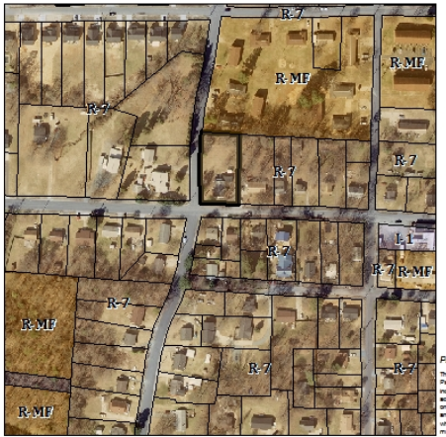

Conformity to the Growth Management Plan (GMP) and Other Adopted Plans
Applicable Goals to Guide Us into the Future
Planning District
North
Development Type
Neighborhood Residential
For single family residential
and townhouses
Characteristics include
open space; parks included with development; pedestrian-oriented; automobile-oriented; sidewalks; street trees; landscaping
Density of 3+ DU/acre
Infrastructure includes
water, sewer, street connectivity and underground utilities
- 6.3.1. Encourage the conversion and development of higher density residential development around the downtown and other designated activity areas. This rezoning would permit the development of higher density residential development in an area that is not around the downtown or a designated activity area.
Applicable Planning District Policies and Recommendations
- 7.3.3.3 Existing infrastructure (i.e. water, sewer, roads, parks, etc.) reduces the costs of new development. The site would use existing city infrastructure.
- 7.3.4.1. Encourage infill development within the district, as well as redevelopment efforts of deteriorating structures. This rezoning would permit the development of an infill parcel with a variety of residential types, including single family, duplexes, multifamily and townhouses, instead of being limited to only single family.

Staff Recommendation
Based on the Growth Management Plan 2000-2020 and the City of Graham Development Ordinance, staff recommends approval of the rezoning. The following supports this recommendation:
- Rezoning the property does further some goals of the Growth Management Plan, such as infill development. It would not be entirely consistent with the Neighborhood Residential development type, however, some adjacent properties are already R-MF.
- Staff feels that a multifamily development on this site could fit in with the surrounding area if properly designed, but simply applying the standards of the Development Ordinance would not guarantee a compatible design and site layout. Multi-family dwelling units that look like townhomes would be in character with the GMP 2020 vision of Neighborhood Residential.

