STAFF REPORT
Prepared by Nathan Page, Interim City Planner

Apex View UBD and Community Center (SUP1501)
Type of Request: Special Use Permit
Meeting Dates
Planning Board on March 17, 2015
City Council on April 14, 2015
Contact Information
Thangaraju Muruegsan
503 Front Ridge Dr. Cary NC 27519
919-308-0255
apexview14@yahoo.com

Summary
This is a request for a Special Use Permit for a Community Center and Unified Business Development (UBD) for property located at 602 W. Elm St. There is an existing building on the site – previously the Simmons Center. The existing drive-thru is to be utilized. The total building square footage is 23,000, with two 4,000 sq ft units, and one 15,000 sq ft unit. Additionally, one of the smaller units is proposed as a community center.
Location
602 W. Elm St
GPIN: 8874759635
Proposed Special Use
Unified Business Development and Community Center
Current Zoning
Light Industrial (I-1) and General Business (B-2)
Overlay District
N/A
Surrounding Zoning
B-2, R-7, & I-1
Surrounding Land Uses
Single Family Houses, Duplex Houses, General Businesses & Light Industrial
Public Water & Sewer
Yes
Floodplain
No
Staff Recommendation
Approval
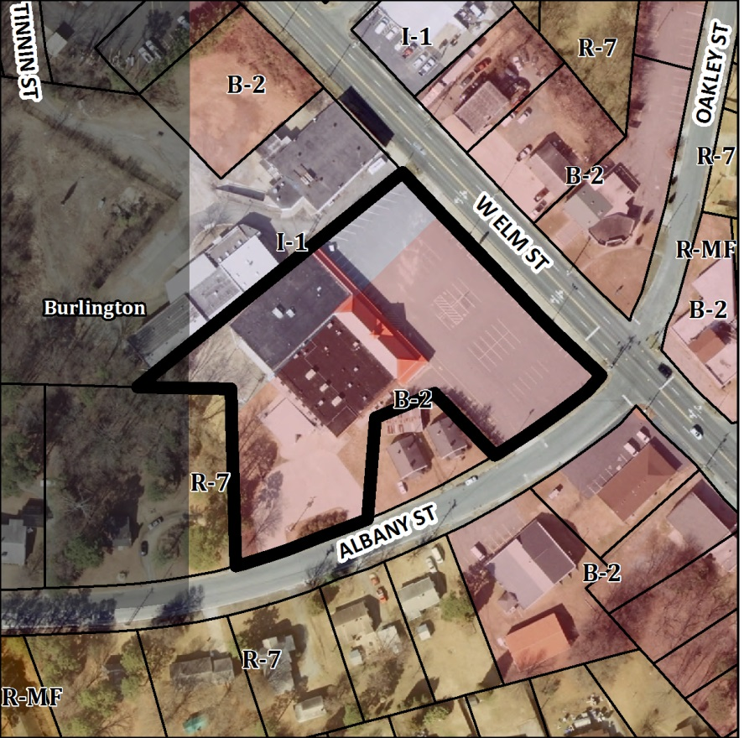
This site was originally developed in 1967, as a multi-tenant building (unified business development). This occurred before the adoption of a Special Uses clause for buildings with multiple tenants in our ordinance. However, given that the site remained vacant for greater than 180 days, a new Special Use Permit is now required to allow for multiple tenants. The location currently has 110 parking spaces.
The building, with a total of about 23,000 sq ft, was subdivided into three units (1, 2, and 3). Unit 1 is about 15,000 sq ft and was used as a supermarket/grocery and meat market business. Units 2 and 3, about 4,000 sq ft and 4,100 sq ft, remained vacant spaces that can be used for any purpose. Currently, one prospective tenant intends to use Unit 2 to run a Party hall/Event center/Community center. Some other proposed uses are to run a non-profit adoption and rescue center, church, gym, or dollar tree etc. in Unit 3.
Since the proposal is to use an existing building as is, no landscaping is required to be installed by the owner. However, if the owner were to expand over 3,000 sq ft or begin new construction, they would have to meet landscaping requirements in relation to the expansion or new construction.
Conformity to the Growth Management Plan (GMP) and Other Adopted Plans
Planning District: North
Description of Development Type
North
Development Toolkit Checklist
Located near a major thoroughfare
With commercial and Office/Institutional Uses
Characteristics include
strip development, automobile orientation, sidewalks, landscaping, buffering, on-site parking
10.001 to 100,000 sq ft of retail
Infrastructure includes water, sewer, street connectivity and underground utilities
Development Type: Highway Commercial
Applicable Goals to Guide Us into the Future
- 6.1.2. Continue to support efforts that identify, restore and/or reuse cultural and historic structures, buildings, monuments, and neighborhoods. The existing structure was constructed in 1967, and this special use permit would allow a reuse of the building which has been vacant for some time.
- 6.2.3. Provide various and adequate community facilities for all residents throughout the city. This special use permit would allow a privately owned community center facility in the northern part of the city.
- 6.3.2 Encourage commercial development that utilizes effective landscaping and buffering to aid in improving the overall aesthetics of the community. The development on this site pre-dates current landscaping ordinances. Unless alterations specified above take place, no landscaping will be required.
- 6.3.2. Prohibit the encroachment of commercial development into established or planned residential areas. The building is located in an identified highway commercial corridor.
- 6.3.8. Encourage the reuse and revitalization of unused or underutilized structures and properties. This special use permit would allow new uses in an existing building which has been underutilized.
Applicable Planning District Policies and Recommendations
- 7.3.4.1.1. Encourage infill development within the district, as well as redevelopment efforts of deteriorating structures. This special use permit would permit the reuse of a building designed as a shopping center.
- 7.3.4.1.5. Prohibit the continuation of additional commercial strip development along major thoroughfares. The development will not add additional commercial strip, but reuse a site which was already developed as auto-oriented.
DRAFT Findings of Fact and Conclusions
In granting a special use permit, the City Council shall find that all of the six conditions listed below have been met, or it shall be denied. Staff has prepared the following DRAFT findings of fact for each of the six conditions. These findings should be modified by the Council as it considers its decision.
1. All applicable regulations of the zoning district in which the use is proposed are complied with.
- The property is zoned B-2 and I-1. “Unified Business Development” is permitted in both the B-2 and I-1 districts. The property will allow all uses allowed in a B-2 district, with the exceptions as noted our ordinance, under section 10.149.
- The existing signs appear to conform to our ordinance. Any new or replaced signs will need sign permits.
- The existing building may be nonconforming with respect to side and rear yard setbacks, but no new construction is proposed that would increase these nonconformities.
- The property may also be nonconforming with regards to screening of adjacent residentially zoned properties.
2. Conditions specific to each use, identified by the Development Ordinance, are complied with.
- There are no conditions specific to “community centers.”
- All uses permitted in the B-2 district are permitted in a Unified Business Development, with the exception of certain uses which are not permitted. The only use specified for this Unified Business Development is the community center. That use is permitted in the B-2 district with a special use permit, and is not prohibited in Unified Business Developments. All future uses to be located within the UBD will be required to obtain a Zoning Permit prior to occupancy.
- All uses shall be completely enclosed in buildings except for plant sales, sidewalk cafes, and permitted drive-in uses. The proposed uses are completely enclosed, with the exception of the proposed drive-thru window. Drive-in establishments offering goods or services directly to customers in parked cars shall be permitted only when the locations of the builds and access drives have been approved by the city council. This proposal includes a drive-thru window, which is seeking the approval of City Council.
- An opaque screen shall be provided wherever, in the city council’s judgment, such screening is necessary to shield adjacent residential districts. There is a residential zone to the rear of the building, zoned R-7, and currently occupied by single family residential.
- Off-street parking for 110 spaces is currently provided. A 15,000 sq ft grocery would require 75 spaces, the 4,100 sq ft community center 21 spaces, and a 4,000 sq ft service establishment dealing frequently with the public another 20. This would require a total of 116. However, if the uses are service establishments dealing infrequently with the public and low-volume retailers, the smaller units could require as little as 14 additional parking spaces, for a total of 89. If all three units require 1 spot per 200 sq ft (the required for high volume retail, service establishments dealing frequently with the public, and community centers), the site would require 6 additional spaces.
- The property is located along a major thoroughfare, minor arterial, or collector street (existing or proposed). This UBD abuts West Elm Street/Highway 87, which is a principal arterial.
- The property is also nonconforming for landscaping, but would not be required to meet current ordinances unless the site adds more than 3,000 sq ft. or constructs a new building .In which case, said modifications would only be required in relation to the expansion or new construction.
3. The use will not materially endanger the public health or safety if located where proposed and developed according to the plan as submitted.
- The reuse of the location as a shopping center will not materially endanger the public health or safety.
4. The use will not substantially injure the value of adjoining property or that the use is a public necessity.
- The proposed UBD will not substantially injure the value of adjoining property.
5. The location and character of the use if developed according to the plan as submitted will be in harmony with the area in which it is to be located and in general conformity with the plan of development for the Graham planning area.
- The community center and unified business district will be located along a major road in a highway commercial corridor and is in general conformity with the Growth Management Plan 2000-2020
6. Satisfactory provision has been made for the following, when applicable: vehicle circulation, parking and loading, service entrances and areas, screening, utilities, signs and lighting, and open space.
- Public water and sewer, parking and loading, service entrances and areas, utilities, and signs and lighting are satisfactorily provided.
- Vehicle circulation is being proposed to remain as is. City Council must approve the proposed location of the drive-thru window, as well as access drives.
- Parking is being proposed to remain as is.
Staff Recommendation
Based on the Growth Management Plan 2000-2020 and the City of Graham Development Ordinance, staff recommends approval of the Special Use Permit. The following supports this recommendation:
- The development furthers goals of the Growth Management Plan and is in conformance with the Highway Commercial development type.
- The development meets all six conditions required by Section 10.144 of the Development Ordinance.

