STAFF REPORT
Prepared by Nathan Page, Interim City Planner

DaVita at Kourescent (SUP8301)
Type of Request: Special Use Permit Amendment
Meeting Dates
Planning Board on March 17, 2015
City Council on April 14, 2015
Contact Information
Richard Porterfield with Total Renal Care, Inc.
2451 Cumberland Parkway #3633
Atlanta, GA 30339 richard.porterfield@davita.com
(240) 893-2521

Summary
This is a request to amend the Special Use Permit for a Unified Business Development (UBD) currently known as Kourescent Square, located on S Main St, W Crescent Square Dr and Auto Park Dr. Specifically, the proposal is to construct a new doctor’s office on the parcel located at the corner of W Crescent Square Drive and Auto Park Drive.
Location
835 S Main St
GPIN: 8883192554, 8883195723 & 8883195412
Proposed Special Use
amendment for
Unified Business Development
Current Zoning
General Business (B-2)
Overlay District
Hwy 87/S Main St
Surrounding Zoning
R-18, R-7, R-12, R-MF,
O-I, B-2 & I-1
Surrounding Land Uses
Single Family Houses, Multifamily, Offices & General Businesses
Public Water & Sewer
Yes
Floodplain
No
Staff Recommendation
Approval with conditions
The Special Use Permit for this shopping center was approved on October 4, 1983 and included a site plan. Because that site plan is unavailable for reference, an amendment to the Special Use Permit is needed in order to add a building on this lot.
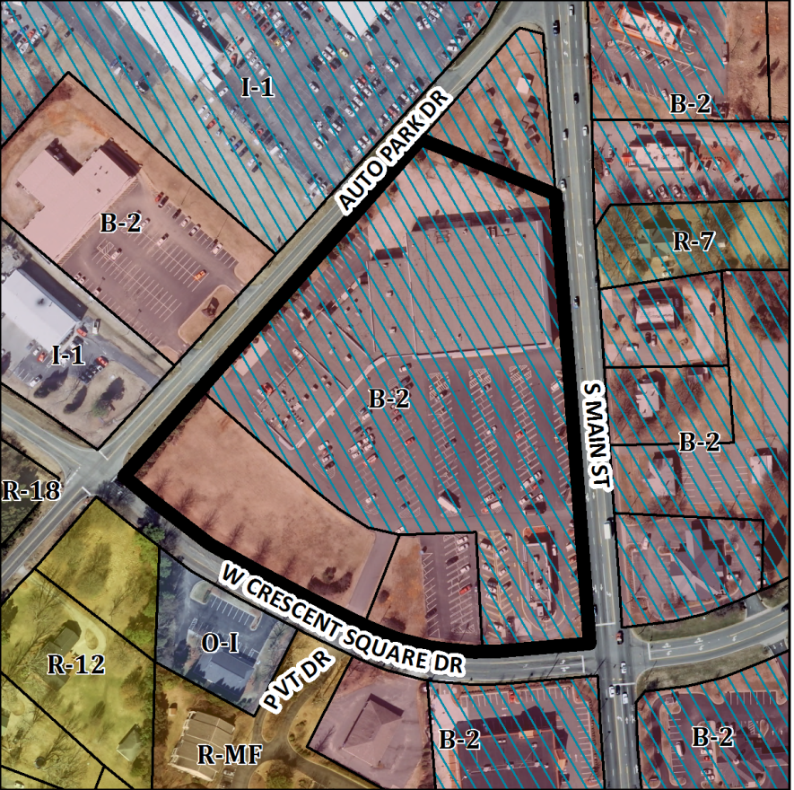
A preliminary site plan, prepared by Triad Design Group, was submitted as part of the application. The proposal is for a 10,616 square foot building and 30 parking spaces, as shown on the preliminary site plan. The location has a 50’ wide natural gas easement which follows along W. Crescent Square Drive and will require internal planting for many of the canopy trees.

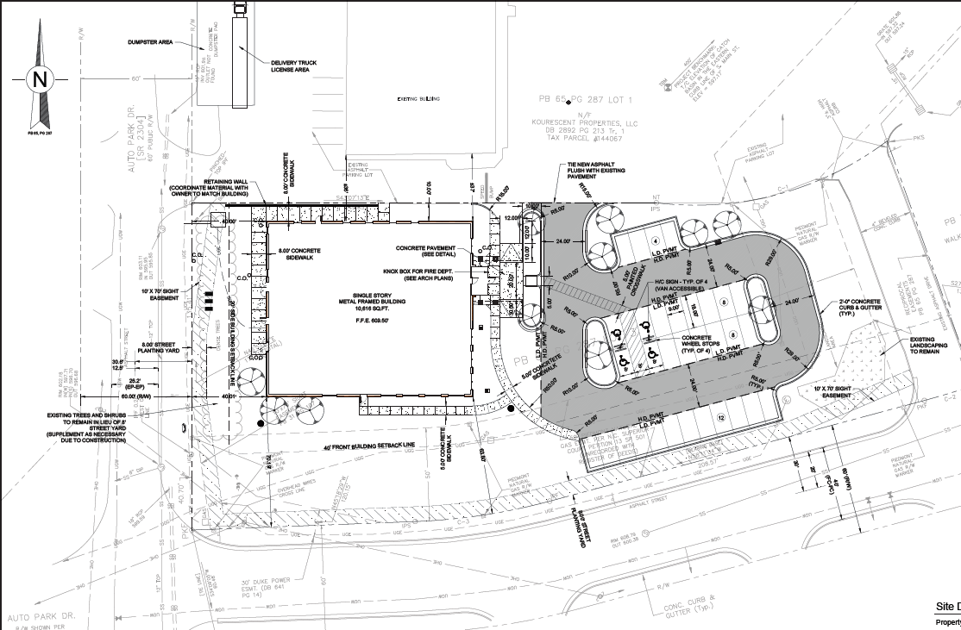
Technical Review Committee
The TRC reviewed the preliminary site plan and met with the applicant on March 2, 2015. Major findings are:
- A reduction in parking should be considered due to the plentiful parking within the UBD.
- Landscaping does not meet ordinance requirements, and should be placed outside of sightlines from the travel lanes (particularly existing the property to the east of the parcel).
- Sidewalks should be provided along both street frontages
- Analysis showing downstream storm drainage capacity should be completed
- Remove retaining wall further from travel lane
- Disturbed area must remain below one acre or all stormwater must be treated on site

Conformity to the Growth Management Plan (GMP) and Other Adopted Plans
Applicable Goals to Guide Us into the Future
Planning District
Central
Development Type
Highway Commercial
Located near a major thoroughfare
For commercial and office/institutional
Characteristics include
automobile-oriented; design requirements; sidewalks;
street trees; landscaping; buffering/screening; parking provided on-site; height of structures regulated; controlled access; building orientation
10,001 to 100,000sf of retail
Infrastructure includes water, sewer, street connectivity and underground utilities
- 6.2.1. Reduce and restrict the number of curb cuts and driveways along major arterials. The proposal uses existing driveways and does not create any new driveways along Auto Park Drive or W Crescent Square Dr.
- 6.3.2. Encourage commercial development within designated village centers as opposed to continued commercial strip development. This commercial development is an amendment to a Special Use Permit for a unified business development that was approved in 1983.
Applicable Planning District Policies and Recommendations
- 7.4.4.1.2. Limit direct highway access or the number of curb cuts to commercial activities by directing development to proposed regional and village centers and requiring internal connectivity between commercial uses, as well as uniformity in design standards. The proposal uses existing driveways and does not create any new driveways along Auto Park Drive or W Crescent Square Dr.
Graham Pedestrian Plan
- Recommends a five-foot sidewalk on this section of Auto Park Drive as a priority project.
DRAFT Findings of Fact and Conclusions
In granting a special use permit, the City Council shall find that all of the six conditions listed below have been met, or it shall be denied. Staff has prepared the following DRAFT findings of fact for each of the six conditions. These findings should be modified by the Council as it considers its decision.
1. All applicable regulations of the zoning district in which the use is proposed are complied with.
The property is zoned B-2. “Unified Business Development” is permitted in the B-2 zoning district with a Special Use Permit. The proposed development meets the area, height and yard regulations. Signs will require a sign permit.
2. Conditions specific to each use, identified by the Development Ordinance, are complied with.
The following requirements are specific to this use:
- Such developments shall abut a major thoroughfare, minor arterial, or collector street (existing or proposed). This existing Unified Business Development abuts NC 87/S Main St, which is a major thoroughfare.
- All uses permitted in the B-2 district are permitted in a Unified Business Development, with the exception of certain uses which are not permitted. Doctor’s offices are permitted in the B-2 district and are not prohibited in a Unified Business Development.
- All business establishments shall be retail or service establishments dealing directly with the public. The proposed office directly serves the public.
- All uses shall be completely enclosed in buildings except for plant sales, sidewalk cafes, and permitted drive-in uses. The proposed office is completely enclosed.
- An opaque screen shall be provided wherever, in the city council’s judgment, such screening is necessary to shield adjacent residential districts. There are no adjacent residential districts that would require screening.
3. The use will not materially endanger the public health or safety if located where proposed and developed according to the plan as submitted.
The proposed office, to be located within an existing Unified Business Development, will not materially endanger the public health or safety.
4. The use will not substantially injure the value of adjoining property or that the use is a public necessity.
The proposed office, to be located within an existing Unified Business Development, will not substantially injure the value of adjoining property.
5. The location and character of the use if developed according to the plan as submitted will be in harmony with the area in which it is to be located and in general conformity with the plan of development for the Graham planning area.
The proposed office, to be located within an existing Unified Business Development, is a commercial use that will be located in an existing highway commercial corridor and is in general conformity with the Growth Management Plan 2000-2020.
6. Satisfactory provision has been made for the following, when applicable: vehicle circulation, parking and loading, service entrances and areas, screening, utilities, signs and lighting, and open space.
Satisfactory provision has been made for vehicle circulation, parking, service entrances and areas, utilities, and lighting.
Staff Recommendation
Based on the Growth Management Plan 2000-2020 and the City of Graham Development Ordinance, staff recommends approval of the Special Use Permit amendment, with the following conditions:
- The applicant will construct a sidewalk along W. Crescent Square Drive and Auto Park Drive.
- A final site plan must be submitted to and approved by the TRC before a building permit and/or certificate of occupancy will be issued. As part of final site plan review, the layout of the parking and sidewalks may change to meet Development ordinance and other requirements, including NCDOT.

The following supports this recommendation:
- The development furthers goals of the Growth Management Plan and will be upon final site plan approval in conformance with the Highway Commercial development type.
- The development will comply upon final site plan approval with the standards of the Development Ordinance.
- The development meets, or will meet upon final site plan approval, all six conditions required by Section 10.144 of the Development Ordinance if approved with the recommended conditions.

