STAFF REPORT
Prepared by Nathan Page, Interim City Planner
Rezoning for Kimrey Road (RZ1502)
Type of Request: Initiate Zoning
Meeting Dates
Planning Board on April 21, 2015
City Council on May 5, 2015
Contact Information
Frankie Maness, City of Graham
PO Drawer 357, Graham, NC 27253
336-570-6700; fmaness@cityofgraham.com

Summary
This is a request to zone the subject properties to I-1. The property is currently vacant and wooded. The stated reason for this rezoning request is “To initiate zoning on a parcel which has applied for annexation into city limits from Alamance County’s Jurisdiction.”
Location
Kimrey Road
GPIN: 9803172212
Current Zoning
N/A
Proposed Zoning
Light Industrial (I-1)
Overlay District
none
Surrounding Zoning
N/A, Mebane Light
Manufacturing (M-2)
Surrounding Land Uses
Vacant, Tree Farm, Distribution Center
Size
84.433 acres and 3.901 acres
Public Water & Sewer
Provided along northwestern portion of tract.
Floodplain
No
Staff Recommendation
Approval
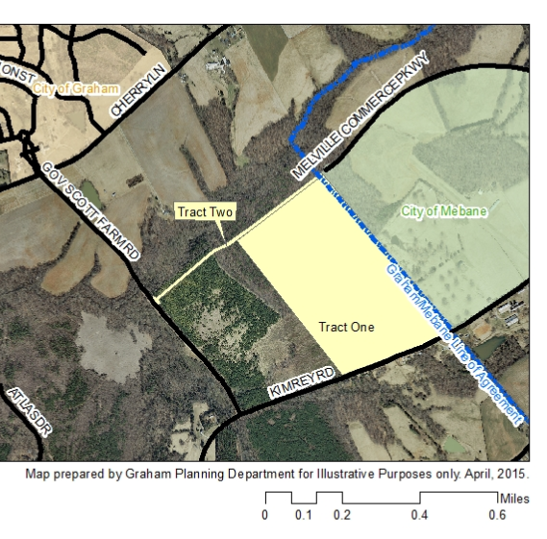

Conformity to the Growth Management Plan (GMP) and Other Adopted Plans
Applicable Goals to Guide Us into the Future
- 7.6.4.1. Encourage the development of an office/industrial/light industrial center developed similar to a corporate campus, office park, or regional employment center. This rezoning would permit a number of types of industry in an area adjacent to a regional industrial center on the future development map.
Planning District
Hawfields
Development Type
Regional Industrial Center
Located near a major thoroughfare with interstate access and large parcels
Industrial characteristics include open space; automobile oriented; design requirements; sidewalks; street trees; landscaping; buffering/screening; parking provided on-site; height of structures regulated; controlled access; building orientation
Size of development more than 10,000sf
Infrastructure includes water, sewer, street connectivity and underground utilities
Applicable Planning District Policies and Recommendations
- None are applicable
Staff Recommendation
Based on the Growth Management Plan 2000-2020 and the City of Graham Development Ordinance, staff recommends approval of the rezoning. The following supports this recommendation:
- Rezoning the property would be consistent with the Regional Industrial Center development type and would further goals of the Growth Management Plan.

