STAFF REPORT
Prepared by Nathan Page, Interim City Planner

Alamance Christian School (SUP1502)
Type of Request: Special Use Permit
Meeting Dates
Planning Board on May 19, 2015
City Council on June 2, 2015
Contact Information
James Fogleman
3056 Rogers Road, Graham NC
336-213-2115
foglemanjames@gmail.com

Summary
This is a request for a Special Use Permit for a School, elementary or secondary for property located at 1336 Town Branch Road. There are existing buildings on the site, currently in use as a non-conforming school. The total building square footage is 21,348.
Location
1336 Town Branch Road
GPIN: 8884967148
Proposed Special Use
School, Elementary or Secondary
Current Zoning
Light Residential (R-18)
Overlay District
N/A
Surrounding Zoning
R-12, R-18, C-MXR, I-2
Surrounding Land Uses
Single Family Houses & Light Industrial
Public Water & Sewer
Yes
Floodplain
No
Staff Recommendation
Approval
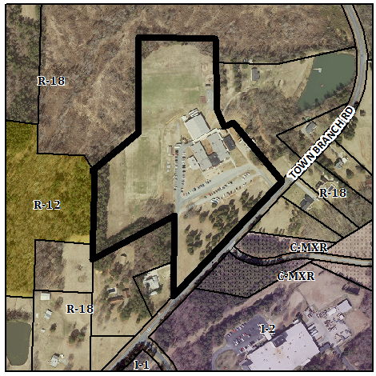
This site was originally developed in 1970, as a religious school. This occurred before the adoption of a Special Uses clause requirement for schools in our ordinance. However, given the school now intends to expand, compliance in the form of a Special Use Permit is now required by the Development Ordinance.
Because the Development Ordinance recognizes School, Elementary or Secondary as a Land Use Classification type 1, no landscape buffering is required. However, if an expansion of more than 3,000 square feet is done the school will be required to plant a street yard and provide parking lot trees sufficient to cover the expansion.
Conformity to the Growth Management Plan (GMP) and Other Adopted Plans
Planning District: North
Description of Development Type
North
Development Toolkit Checklist
Located near a major thoroughfare
Single family residences and townhomes
Characteristics include
open space, parks, pedestrian orientation, sidewalks, street trees, and landscaping
3-5 Dwelling Units/ Acre
Infrastructure includes water, sewer, street connectivity and underground utilities
Development Type: Neighborhood Residential
Applicable Goals to Guide Us into the Future
- 6.1.2. Continue to support efforts that identify, restore and/or reuse cultural and historic structures, buildings, monuments, and neighborhoods. The existing structure was constructed in 1970, and this special use permit would allow use of an existing private school to conform with our updated ordinance.
- 6.2.3. Provide various and adequate community facilities for all residents throughout the city. This special use permit would allow a privately owned educational facility in the eastern part of the city.
- 6.3.2 Encourage commercial development that utilizes effective landscaping and buffering to aid in improving the overall aesthetics of the community. The development on this site pre-dates current landscaping ordinances. However, if an expansion of more than 3,000 square feet takes place the school would need to comply with current ordinance requirements.
- 6.3.2. Prohibit the encroachment of commercial development into established or planned residential areas. The school is located in a residential zone between residential and industrial areas.
- 6.3.8. Encourage the reuse and revitalization of unused or underutilized structures and properties. This special use permit would allow continued use in an existing building.
Applicable Planning District Policies and Recommendations
- 7.3.4.1.1. Encourage infill development within the district, as well as redevelopment efforts of deteriorating structures. This special use permit would bring into conformance the continued use of a building designed as a school.
DRAFT Findings of Fact and Conclusions
In granting a special use permit, the City Council shall find that all of the six conditions listed below have been met, or it shall be denied. Staff has prepared the following DRAFT findings of fact for each of the six conditions. These findings should be modified by the Council as it considers its decision.
1. All applicable regulations of the zoning district in which the use is proposed are complied with.
- The property is zoned R-18, a school is permitted in this zone only with a special use permit.
2. Conditions specific to each use, identified by the Development Ordinance, are complied with.
- There are no conditions specific to “school, elementary or secondary.”
3. The use will not materially endanger the public health or safety if located where proposed and developed according to the plan as submitted.
- The continued use of the location as a school will not materially endanger the public health or safety.
4. The use will not substantially injure the value of adjoining property or that the use is a public necessity.
- The continued use of the location of a school will not substantially injure the value of adjoining property.
5. The location and character of the use if developed according to the plan as submitted will be in harmony with the area in which it is to be located and in general conformity with the plan of development for the Graham planning area.
- The school is located in a neighborhood residential section of Graham, and is in general conformity with the Growth Management Plan 2000-2020
6. Satisfactory provision has been made for the following, when applicable: vehicle circulation, parking and loading, service entrances and areas, screening, utilities, signs and lighting, and open space.
- Public water and sewer, parking and loading, service entrances and areas, utilities, and signs and lighting are satisfactorily provided.
- Vehicle circulation is being proposed to remain as is. City Council must approve access drives.
- Parking is being proposed to remain as is.
Staff Recommendation
Based on the Growth Management Plan 2000-2020 and the City of Graham Development Ordinance, staff recommends approval of the Special Use Permit. The following supports this recommendation:
- The development furthers goals of the Growth Management Plan and is in conformance with the Neighborhood Residential development type.
- The development meets all six conditions required by Section 10.144 of the Development Ordinance.

