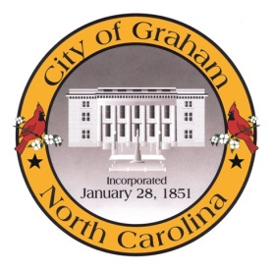

Planning Board

Meeting Agenda
February 17, 2015 at 7:00pm
Council Chambers, 201 S Main St
Meeting Called to Order, Invocation, and Overview of Board and general meeting rules
1. Public comment on non-agenda items
2. Approve minutes of the January 20, 2015 meeting
3. Committee Reports
4. Old Business
5. New Business
a. Apex View UBD & Community Center (SUP1501). Request by Thangaraju Muruegsan for a Special Use Permit for a Community Center and Unified Business Development on property located at 602 W Elm St (GPIN 8874759635).
b. 2035 Comprehensive Plan. Review of the final draft and recommendation on adoption.
Adjourn
A complete agenda packet is available at www.cityofgraham.com

