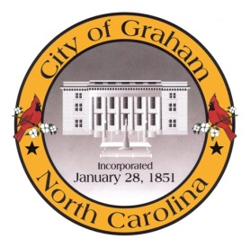

Planning Board

Meeting Agenda
May 19, 2015 at 7:00pm
Council Chambers, 201 S Main St
Meeting Called to Order, Invocation, and Overview of Board and general meeting rules
1. Public comment on non-agenda items
2. Approve minutes of the April 21, 2015 meeting
3. Old Business
a. Discussion of Development Ordinance
4. New Business
a. Alamance Christian School (SPU 1502); This is an application from an existing school who is intending to come into compliance with current regulations to allow for future expansion.
Adjourn
A complete agenda packet is available at www.cityofgraham.com

