STAFF REPORT
Prepared by Nathan Page, City Planner

Watercourse Modeling (VR1501)
Type of Request: Variance
Meeting Dates
Board of Adjustment on August 18, 2015
Contact Information
Pumpkin Hill Mill, LLC
463 ½ Carolina Circle, Winston Salem NC 27104
336-499-1963; admin@ThirdWaveHousing.com

Summary
This is a request for a variance from the minimum dimension requirement of the open space regulation (10.136.18.2) and the maximum distance to parking (10.241).
Location
219 West Harden Street
GPIN: 8884056108
Current Zoning
Multifamily Residential (R-MF)
Current Use
Vacant
Surrounding Zoning
R-7, R-MF, I-1, O-I, & B-2
Surrounding Land Uses
Single Family Houses, Multi-Family Houses, General Business, Vacant, and Undeveloped
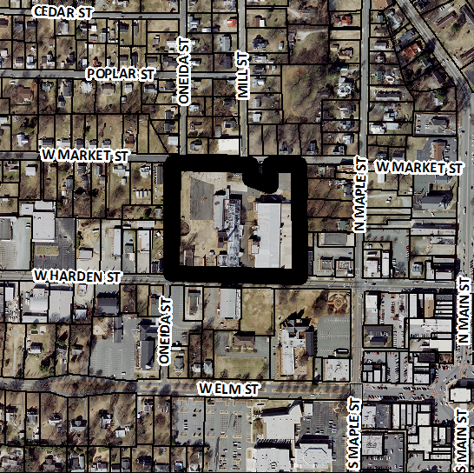
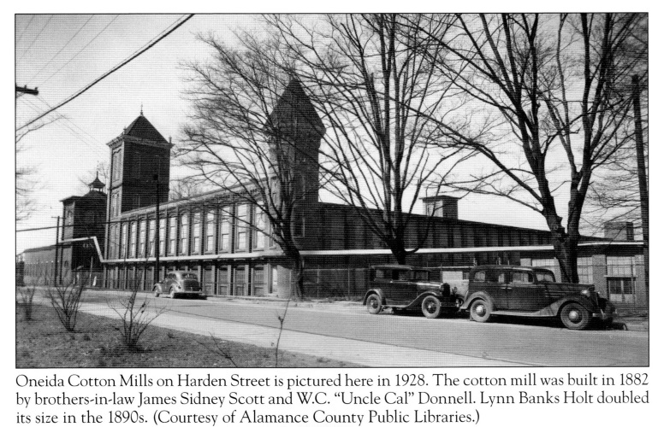
Attached is a draft of a Resolution for the Board to consider when making its decision. This draft Resolution should be modified as the Board sees fit and is only provided by staff as a template

