STAFF REPORT
Prepared by Nathan Page, City Planner

Dodson Carport (VR1503)
Type of Request: Variance
Meeting Dates
Board of Adjustment on September 15, 2015
Contact Information
Larry and Jo Warren
1401 E Gilbreath Street, Graham, NC 27253
336-227-8744; jojowarren@bellsouth.net

Summary
This is a request for a variance from accessory buildings in residential districts being restricted to the rear and side yards. The stated purpose of this request is “We are requesting to build a much needed Storage Building on our property in order to store our tools, materials, tractor, lawn mower, trailer, work truck etc.”
Location
1401 E Gilbreath St
GPIN: 8883954667
Current Zoning
Residential (low density)
(R-15)
Current Use
Single Family Dwelling
Surrounding Zoning
R-18 & I-2
Surrounding Land Uses
Single Family Houses and Graveyard
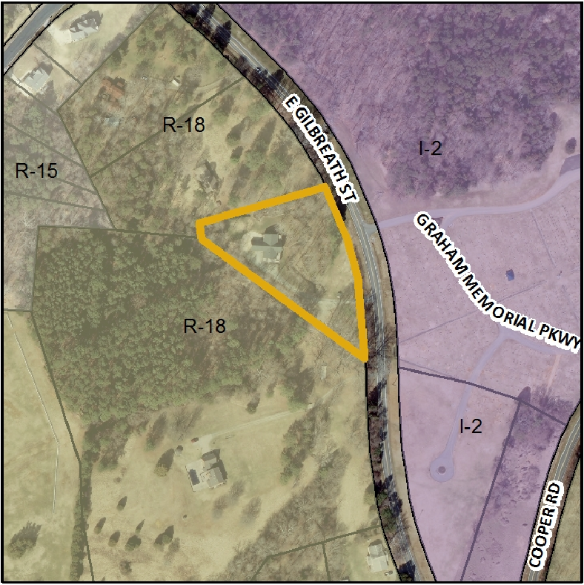
Attached is a draft of a Resolution for the Board to consider when making its decision. This draft Resolution should be modified as the Board sees fit and is only provided by staff as a template.

