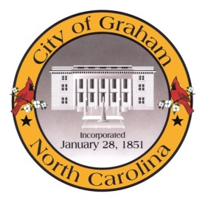

Planning Board

Meeting Agenda
October 20, 2015 at 7:00pm
Council Chambers, 201 S Main St
Meeting Called to Order, Invocation, and Overview of Board and general meeting rules
1. Public comment on non-agenda items
2. Approve minutes of the August 18, 2015 meeting
3. Old Business
a. Mayor Peterman regarding the City of Graham Development Ordinances.
4. New Business
a. Florence Rezoning (RZ1503). An application by Karen Tatko for a rezoning from R-12 to R-7 at 111 Florence Street.
Adjourn
A complete agenda packet is available at www.cityofgraham.com

