STAFF REPORT
Prepared by Nathan Page, City Planner

Florence R-7 (RZ1503)
Type of Request: Rezoning
Meeting Dates
Planning Board on October 20, 2015
City Council on November 3, 2015
Contact Information
Karen Tatko
1147 Sam Lee Road, Graham NC 27253
336-269-2789; ktatko53@yahoo.com

Summary
This is a request to rezone the subject property from R-12 to
R-7. The property is currently vacant. The stated reason for this rezoning request is “to get single family residence of equal or greater size as previously existed.”
Location
111 Florence St
GPIN: 8883176777
Current Zoning
Residential (medium density)
(R-12)
Proposed Zoning
Residential (high density) (R-7)
Overlay District
none
Surrounding Zoning
R-12 & R-MF
Surrounding Land Uses
Multifamily and Vacant
Size
0.18 acres
Public Water & Sewer
Yes
Floodplain
No
Staff Recommendation
Approval
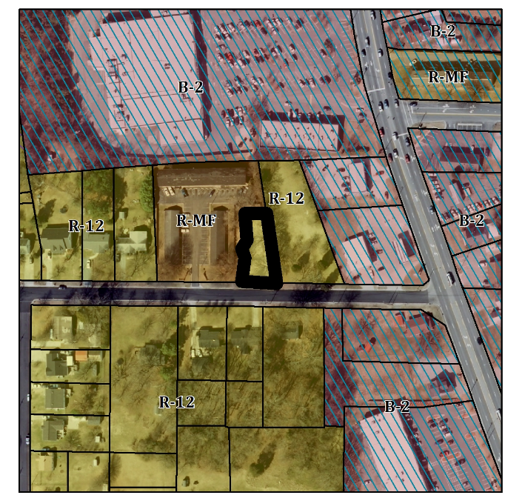

Conformity to the Graham 2035 Comprehensive Plan (GCP) and Other Adopted Plans
Applicable Policies;
Planning Type
Neighborhood
Development Type
Suburban Residential
For single family residential, townhouses, duplexes, accessory dwelling units, and small scale multi-family dwelling of twelve units or less.
Buildings should be located near the front of the property line, oriented towards the street, and include front porches and other private outdoor spaces.
Recess garages behind the front of buildings to avoid streetscapes dominated by garage doors.
Density of 3 to 6 DU/acre
- 3.3.2 Focused Development. In order to maintain Graham’s affordability and promote growth, the city will facilitate smart growth development by promoting infill development and focused, walkable, and mixed use built environments. This parcel is a walkable distance to commercial uses, and would permit infill development where a single family house once stood.
- 5.1.1 Housing Variety. Encourage a mix of housing types within Graham to increase choice. These can include single family dwelling units, multifamily dwelling units, small units, pre-fabricated homes, co-housing, and clustered housing. This parcel is adjacent to a multi-family parcel, and a parcel currently zoned R-12.
Applicable Strategies;
- 4.3.1 Land Use Patterns. Promote development of efficient land use patterns to allow continued quality and efficiency of water systems. Discourage the extension of water service into areas that are not most suitable for development. The site would use existing city infrastructure.

Staff Recommendation
Based on the Graham 2035 Comprehensive Plan and the City of Graham Development Ordinance, staff recommends approval of the rezoning. The following supports this recommendation:
- Rezoning the property would be consistence with the Suburban Residential type and furthers the policies and strategies put forth by the Graham 2035 Comprehensive Plan, such as infill development.

