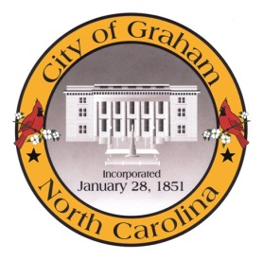

Planning Board

Meeting Agenda
November 17, 2015 immediately following the Board of Adjustment Meeting
Council Chambers, 201 S Main St
Meeting Called to Order, Invocation, and Overview of Board and general meeting rules
1. Public comment on non-agenda items
2. Approve minutes of the October 27, 2015 meeting
3. Old Business
a. Discussion regarding the City of Graham Development Ordinances.
4. New Business
Adjourn
A complete agenda packet is available at www.cityofgraham.com

