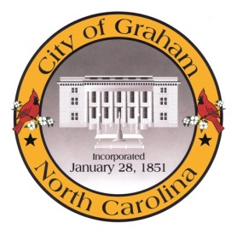

Planning Board

Meeting Agenda
December 15, 2015 at 7:00 PM
Council Chambers, 201 S Main St
Meeting Called to Order, Invocation, and Overview of Board and general meeting rules
1. Public comment on non-agenda items
2. Approve minutes of the November 17, 2015 meeting
3. New Business
a. Rogers/Windsor Rezoning (RZ1504)
4. Old Business
a. Discussion regarding the City of Graham Development Ordinances
AM1501 Electronic Billboards
AM1502 Construction Surety
AM1503 Future Development
AM1504 Handicapped Parking
AM1505 Parking Maximums
AM1506 Sidewalk Payment-in-Lieu
AM1507 Solar Farms
Adjourn
A complete agenda packet is available at www.cityofgraham.com

