STAFF REPORT
Prepared by Nathan Page, City Planner
Variance for Side Yard at 909 Washington St (VR1601)
Type of Request: Variance
Meeting Dates
Board of Adjustment on February 16, 2016
Contact Information
Washington Properties II, LLC
913 Washington St, Graham, NC 27253
336-570-2282; rs_csm@bellsouth.net

Summary
Project Name
Variance for Side Yard at 909 Washington St (VR1601)
Location
909 Washington St
GPIN: 8884084619
Current Zoning
Light Industrial (I-1)
Current Use
Recycling Center
Surrounding Zoning
R-7, B-3, I-1 & I-2
Surrounding Land Uses
Single Family Dwellings, Neighborhood Businesses, Light Industry, Cemetery, Railroad
This is a request for a variance from the required side yard setback, which is 20 feet in the I-1 zoning district. The stated purpose of this request is as follows: “Owner wants to divide the property for a future sale. The distance between the two buildings on the current property is 16 feet which does not meet the side setback requirement of 20 feet. Access easements will be provided for both buildings in the rear of the building from North Main Street and between the buildings where the variance is being requested.”
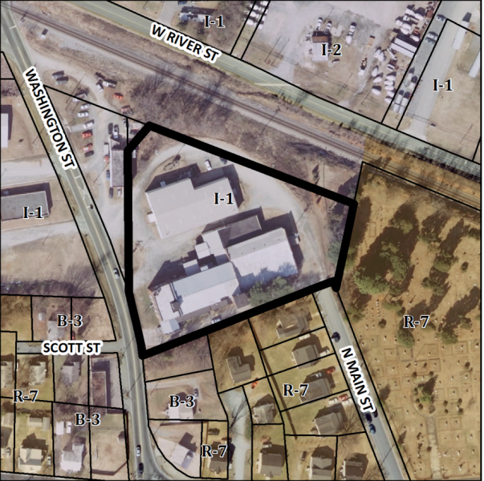
Attached is a draft of a Resolution for the Board to consider when making its decision. This draft Resolution should be modified as the Board sees fit and is only provided by staff as a template.

