STAFF REPORT
Prepared by Nathan Page, City Planner

Forks of the Alamance (S1502)
Type of Request: Major Subdivision
Meeting Dates
Planning Board on February 16, 2016
City Council on March 1, 2016
Contact Information
David Michaels 5603 New Garden Village Dr, Greensboro, NC 27410
336-207-8003; dmichaels@windsorhomes.us

Summary
This is a request to create a new major subdivision on the subject property for 101 lots. The property is currently vacant.
Location
Rogers Road
GPIN: 8872970504
Current Zoning
High Density
Residential (R-9)
Overlay District
none
Surrounding Zoning
R-9
Surrounding Land Uses
Single family
Size
60.3 acres
Public Water & Sewer
New Infrastructure Proposed
Floodplain
Yes
Staff Recommendation
Approval, with conditions
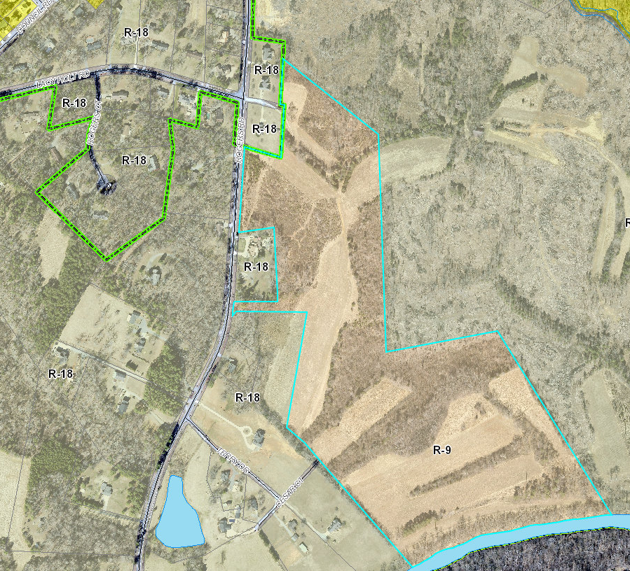

Technical Review Committee
The Technical Review Committee reviewed the application and provided comments to the applicant via the City Planner. As of the publishing of this agenda packet, the applicant had not responded to the comments. There are substantial required revisions to the plans, but they do not affect the number of proposed lots, nor the access points from Rogers Road.
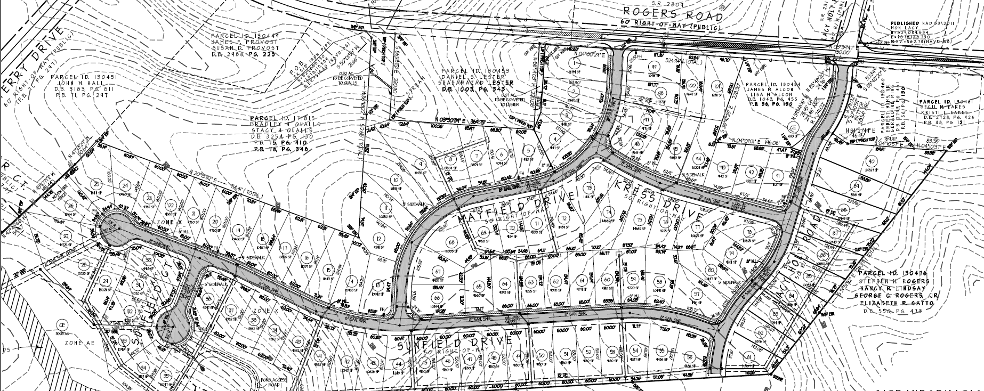
Conformity to The Graham 2035 Comprehensive Plan and Other Adopted Plans
Development Type
Suburban Residential
Located near a major thoroughfare
For single family residential
Characteristics include
sidewalks on both sides, street trees at 30-40 feet intervals, and block lengths less than 600 feet
Density of 3 to 6 DU/acre
Infrastructure includes
water, sewer, street connectivity and underground utilities
From Our Vision
- A Healthy Environment New growth in Graham will occur sustainably, with minimal impact on the natural environment. Conservation efforts will maintain the health of the watershed, preserve habitat for native plants and animals, as well as reduce pollution through investments in renewable energy sources, clean transportation options, and resource conservation. This subdivision proposes approximately 30 acres of open space, mostly in the floodplain. This protection of existing floodplain will reduce downstream flood events and protect habitat. The common areas are identified in our Future Land Use Map as areas to protect. Additionally, it will begin to lay out a greenway connection to the MST/HRT along Big Alamance Creek.
Applicable Strategies and Policies
- Policy 3.2.3 Fewer Dead-end Streets Discourage or prohibit the development of cul-de-sacs and dead-end streets in new projects. While the proposal will have a stub out to two adjacent properties, the only dead-end is the cul-de-sac of Sunfield Ct.
- Policy 3.2.4 Greenway System Promote a greenway system that links together the City’s recreational resources and provides connections to commercial, employment, and residential areas. Greenways along stream buffers should be prioritized in order to protect the stream watershed. This parcel contains land that a pedestrian easement will be required as part of approval upon. Additionally, the Alamance Parks and Recreation department may attempt to acquire a larger portion in the future, but the land here is protected as common space.
- Strategy 4.2.1 Greenways Continue to develop a greenway system that links together the City’s recreational resources.
- Policy 4.3.1 Land Use Patterns Promote development of efficient land use patterns to allow continued quality and efficiency of water systems. Discourage the extension of water service into areas that are not most suitable for development. This proposal keeps almost all of the development out of the floodplains, and allows for connection from the stubs to the east and south for future development on suitable land.
Staff Recommendation
Based on The Graham 2035 Comprehensive Plan and the City of Graham Development Ordinance, staff recommends approval of the subdivision, with the following conditions;
- A final site plan must be submitted to and approved by the TRC before a building permit and/or certificate of occupancy will be issued.

The following supports this recommendation:
Allowing a high density subdivision in this location removes households from the potential harm from floodways, and protects greenspace and promotes a greenway trail system.

