STAFF REPORT
Prepared by Nathan Page, City Planner

Gilbreath B-2 (RZ1601)
Type of Request: Rezoning
Meeting Dates
Planning Board on February 16, 2016
City Council on March 1, 2016
Contact Information
Chad Oakley
114 W Gilbreath St, Graham NC 27253
336-213-8972; oakleycboy@aol.com

Summary
This is a request to rezone the subject property from R-7 to
B-2. One of the two lots is currently occupied by a single family dwelling. The stated reason for this rezoning request is “to have the ability to lease the property to an accountant, financial planner, etc. and keep the current use as a single family dwelling compliant with rezoning of B-2.”
Location
114 W. Gilbreath St
GPIN: 8884121125 and 8884120240
Current Zoning
Residential (high density)
(R-7)
Proposed Zoning
General Business (B -2)
Overlay District
none
Surrounding Zoning
R-7
Surrounding Land Uses
Single Family Homes
Size
1 acre
Public Water & Sewer
Yes
Floodplain
No
Staff Recommendation
Denial
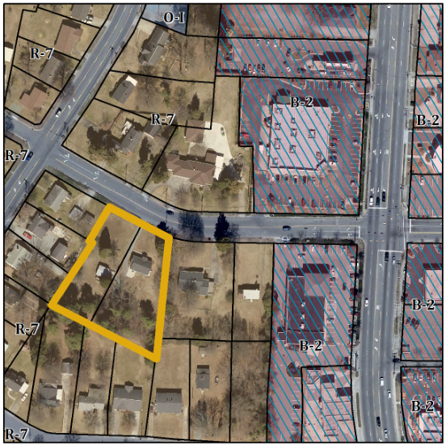

Conformity to the Graham 2035 Comprehensive Plan (GCP) and Other Adopted Plans
Applicable Policies;
Description of Development Type
Downtown Residential
Development Toolkit Checklist
Located near a major thoroughfare
For single family residential
and duplexes
Characteristics include
porches, sidewalks, street trees, and garages setback from the front of the home
Density of 3-6 DU/acre
New homes should consider adjacent lot sizes and building orientations
- 2.2.3 Retail Centers Because of market limitations on the amount of retail space the City can viably support, Graham promotes retail within focused centers of activity that will host a large variety of small retail spaces while generally discouraging sprawling isolated retail that does not promote a cohesive urban fabric. Permitting a B-2 zoning on this lot would make retail centers use by right outside of an identified node.
Applicable Strategies;
- 1.1.5 Discourage Strip Development Discourage strip development along transportation arteries and proposed interstate interchanges by directing these commercial activities to proposed activity centers. Permitting an extension of the business district down side streets while we have vacant commercial buildings along the main transportation corridors and in the vicinity of the Downtown will have adverse effects on both businesses and neighborhoods.

Staff Recommendation
Based on the Graham 2035 Comprehensive Plan and the City of Graham Development Ordinance, staff recommends denial of the rezoning. The following supports this recommendation:
- Rezoning the property would be inconsistent with the Downtown Residential type. A B-2 zone permits auto body shops, used tire sales, farm equipment sales, a miniature golf course, hospitals, etc., which may not fit the existing neighborhood.

