STAFF REPORT
Prepared by Nathan Page, City Planner

Rogers Contractor (CR1602)
Type of Request: Conditional Rezoning
Meeting Dates
Planning Board on April 19, 2016
City Council on May 3, 2016
Contact Information
Charles Terry
2917 Rogers Road, Graham NC 27253
336-697-8803

Summary
This is a request to rezone the subject property from R-12 to C-B. The applicant is proposing to “use the place I live at as my business.” The property was functioning as a Home Occupation, however exceeded that definition and was issued a notice of violation on March 8th, subsequent to which Andy requested alternative methods under which his property could come into compliance.
Project Name
Rogers Contractor (CR1602)
Location
1129 Rogers Road
GPIN: 8883166529
Size
0.7 acres
Proposed Density
N/A
Current Zoning
Residential (Medium density)
(R-12)
Proposed Zoning
Conditional Business (C-B)
Surrounding Zoning
R-12
Surrounding Land Uses
Single Family, Vacant
Staff Recommendation
Denial
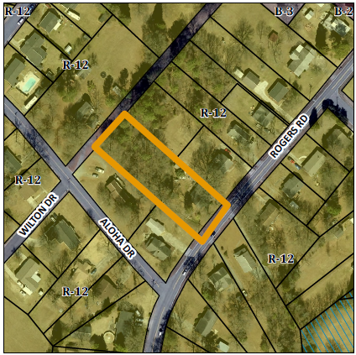

The applicant is proposing to rezone the property to C-B in accordance with the attached site plan. The proposal is for numerous outbuildings to be used for commercial purposes within a residential district. The home currently has access only along Rogers Road. The proposal includes the following specifics:
- A fence to buffer the west and eastern portion of the lot.
- Outbuildings will be used for general storage of construction materials.
Conformity to The Graham 2035 Comprehensive Plan (GCP) and Other Adopted Plans
Development Type: Suburban Residential
Description of Development Type
Suburban Residential
Located near a major thoroughfare
For single family residential
Characteristics include
sidewalks on both sides, street trees at 30-40 feet intervals, and block lengths less than 600 feet
Density of 3 to 6 DU/acre
Infrastructure includes
water, sewer, street connectivity and underground utilities

Principle and Supporting Uses
- Principle- single-family homes, duplexes, townhomes, and small scale multi-family dwelling units.
- Supporting- Places of worship, day cares, park facilities, schools, civic spaces, accessory dwelling units. Neighborhood centers may include neighborhood-oriented commercial, small professional offices, live-work units, and home occupations provided they do not generate excessive traffic and parking. The Home Occupation is intended to be conducted within a dwelling unit, and not take place in the rear yard.
Applicable Policies and Recommendations
- 2.3.1 Focused Development In order to maintain Graham’s affordability and promote growth, the City will facilitate smart growth development by promoting infill development and focused, walkable, and mixed use built environments. While the addition of a mixed use business to a residential neighborhood is frequently recommended by this plan, typically the envisioned uses are those that are permitted within the B-3 (Neighborhood Business). While the contractor’s office may not be a noisy neighbor, the storage of trucks and heavy equipment, as well as storage of materials, makes it a less desirable neighbor than a residence.

Staff Recommendation
Based on The Graham 2035 Comprehensive Plan and the City of Graham Development Ordinance, staff recommends denial of the conditional rezoning.
The following supports this recommendation:
- Because the development has grown beyond the scope of what the Development Ordinance permits as a home occupation, the business shall now move into a zone more suitable for the storage of gravel, dump trucks and bulldozers.

