STAFF REPORT
Prepared by Nathan Page, City Planner

Knightdale Residential (RZ1602)
Type of Request: Rezoning
Meeting Dates
Planning Board on June 21, 2016
City Council on July 5, 2016
Contact Information
Chris Foust, Laurelton Village, INC
1851 S Main Street
Graham NC 27253
336-516-1888; kfoust@mcphersongrading.com

Summary
This is a request to rezone the subject property from R-18 to
R-9. The property currently has a single family home upon it. There is water and sewer available along Lacy Holt Road.
Location
2225 Lacy Holt Rd
GPIN: 8872499679/
8872590389
Current Zoning
Residential (low density)
(R-18)
Proposed Zoning
Residential (high density) (R-9)
Overlay District
none
Surrounding Zoning
R-18, R-12
Surrounding Land Uses
Single Family and Vacant
Size
17.08 acres
Public Water & Sewer
Yes
Floodplain
No
Staff Recommendation
Approval
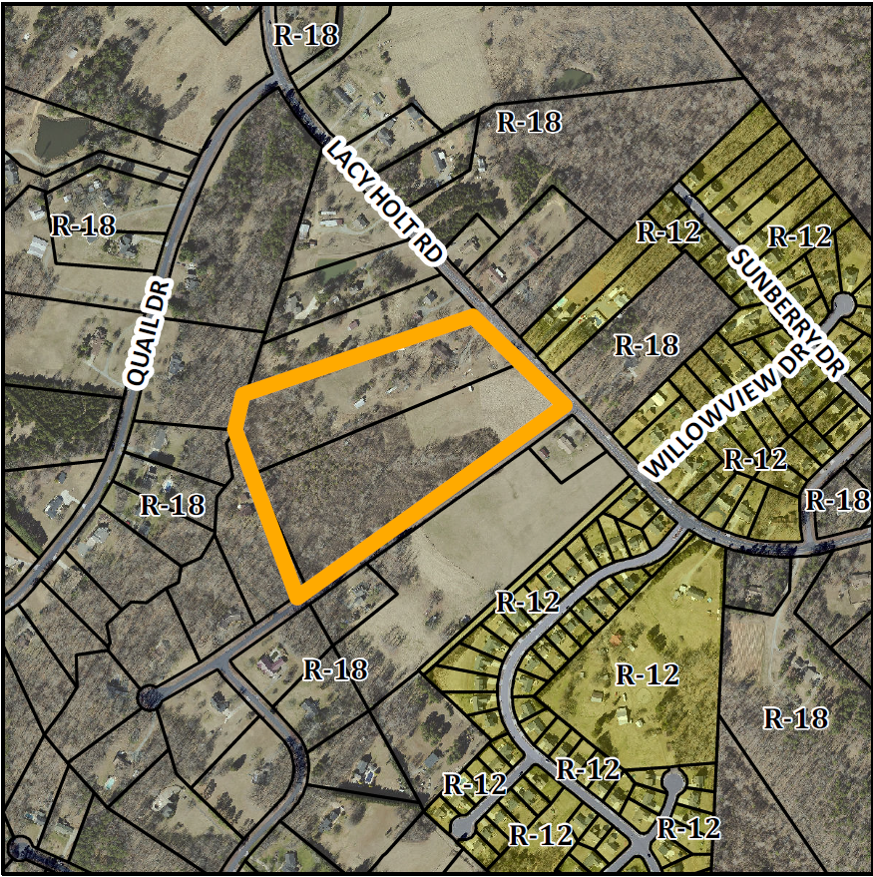

Conformity to the Graham 2035 Comprehensive Plan (GCP) and Other Adopted Plans
Applicable Policies;
Planning Type
Neighborhood
Development Type
Suburban Residential
For single family residential, townhouses, duplexes, accessory dwelling units, and small scale multi-family dwelling of twelve units or less.
Buildings should be located near the front of the property line, oriented towards the street, and include front porches and other private outdoor spaces.
Recess garages behind the front of buildings to avoid streetscapes dominated by garage doors.
Density of 3 to 6 DU/acre
- 5.1.1 Housing Variety. Encourage a mix of housing types within Graham to increase choice. These can include single family dwelling units, multi family dwelling units, small units, prefabricated homes, cohousing, and clustered housing. The amendment will provide additional small lot homes in the southwestern portion of Graham.
- 4.3.1 Land Use Patterns. Promote development of efficient land use patterns to allow continued quality and efficiency of water systems. Discourage the extension of water service into areas that are not most suitable for development. The site would use existing city infrastructure, and would facilitate later development of existing adjacent property.

Staff Recommendation
Based on the Graham 2035 Comprehensive Plan and the City of Graham Development Ordinance, staff recommends approval of the rezoning. The following supports this recommendation:
- Rezoning the property would be in consistence with the Suburban Residential type and furthers the policies and strategies put forth by the Graham 2035 Comprehensive Plan, such as efficient development.

