STAFF REPORT
Prepared by Nathan Page, Planning Director

Shamrock Valley (CR0501)
Type of Request: Conditional Rezoning Amendment
Meeting Dates
Planning Board on July 19, 2016
City Council on August 2, 2016
Contact Information
Jimmy Collins, Concept Builders
PO Box 2507
Burlington NC, 27216
336-228-0490; jcollins@conceptbuilders.net

Summary
This is a request to amend the existing Conditional Rezoning application for the townhome section (Shamrock Pointe) of Shamrock Valley. The amendment will permit the homeowners to build to their rear property lines. Some of the homes already have sunrooms and porches extending beyond the footprint shown on the plan approved in 2005. This amendment, which was signed by all of the property owners in the townhome section, would allow these to come into conformance, and would allow the other properties to make the same modifications.
Location
Monroe Holt and Lacy Holt Rd
GPIN: see application
Current Zoning
Conditional Residential (C-R)
Proposed Zoning
Conditional Residential (C-R)
Overlay District
none
Surrounding Zoning
R-18, C-MXR, Vacant
Surrounding Land Uses
Single Family Houses
Size
7.03 acres
Density
9 DU/acre
Public Water & Sewer
Yes
Floodplain
No
Staff Recommendation
Approval
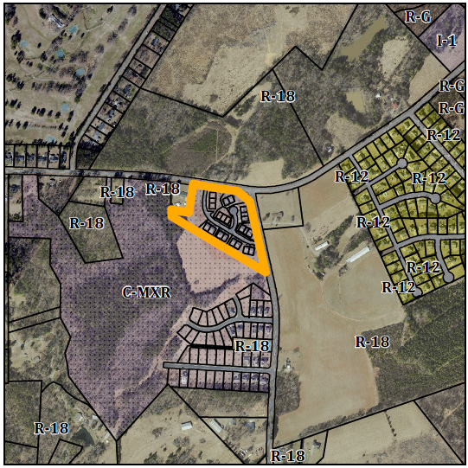

Conformity to The Graham 2035 Comprehensive Plan (GCP) and Other Adopted Plans
Development Type: Suburban Residential
Description of Development Type
Suburban Residential
Development Toolkit Checklist
Located near a major thoroughfare
Predominantly detached single-family homes
Characteristics include
porches, sidewalks, street trees, and garages setback from the front of the home
Density of 3-6 DU/acre
New neighborhoods should consider a variety of lot sizes with consistent setbacks along the same street
Applicable Strategies to Guide Us into the Future
- 4.3.1 Land Use Patterns Promote development of efficient land use patterns to allow continued quality and efficiency of water systems. Discourage the extension of water service into areas that are not most suitable for development. This proposal takes advantage of existing infrastructure, and would allow the neighbors to do what they wish with their backyards.
Applicable Policies and Recommendations
- 2.2.1 Focused Development In order to maintain Graham’s affordability and promote growth, the City will facilitate smart growth development by promoting infill development and focused, walkable, and mixed use built environments. While the density is higher than that recommended by the 2035 Comprehensive Plan, the townhomes have already been approved. This amendment deals only with the rear yard of existing homes.

Staff Recommendation
Based on The Graham 2035 Comprehensive Plan and the City of Graham Development Ordinance, staff recommends approval of the amendment to the existing conditional rezoning:
The following supports this recommendation:
- While the development doesn’t strictly comply with the Suburban Residential type, the homeowners of the entire development have requested to be permitted to construct porches, sunrooms or decks to be better able to use their own backyards.

