STAFF REPORT
Prepared by Nathan Page, City Planner

Jay Industrial (RZ1604)
Type of Request: Rezoning
Meeting Dates
Planning Board on July 19, 2016
City Council on August 2, 2016
Contact Information
Brian Hall, Empire Building, LLC.
P O Box 8050, Greensboro NC 27419
336-544-2600; bhall@sametcorp.com

Summary
This is a request to rezone the subject property from I-1 to
I-2. The property is currently occupied by a single structure. The stated reason for this rezoning request is “to permit the finishing of textile products.”
Location
1201 Jay Lane
GPIN: 8894142534
Current Zoning
Industrial (Light, I-1)
Proposed Zoning
Industrial (Heavy, I-2)
Overlay District
none
Surrounding Zoning
I-2, I-1
Surrounding Land Uses
Heavy and Light Industrial
Size
5.5 acres
Public Water & Sewer
Yes
Floodplain
No
Staff Recommendation
Approval
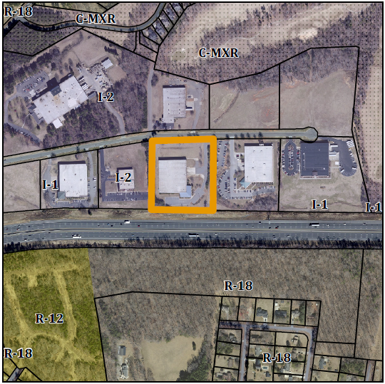

Conformity to the Graham 2035 Comprehensive Plan (GCP) and Other Adopted Plans
Applicable Policies and Strategies;
Description of Development Type
Industrial
Development Toolkit Checklist
Easy access to I-40/85
Potentially noxious, requiring adequate buffers
Characteristics include
limited setbacks in other to use land and infrastructure efficiently, heavy buffering from nearby residential, minimal adverse environmental impacts
Density of 0.3 to 0.5 FAR
New homes should consider adjacent lot sizes and building orientations
- 2.4.2 Promote Industrial Redevelopment Encourage reinvestment and intensification at existing industrial sites. Encourage redevelopment of existing buildings and infrastructure for industrial growth. This building has been underutilized for years. The rezoning is likely because of a prospective buyer who would like to use the location for textile finishing, a use prohibited in Light Industrial, but permitted in Heavy Industrial.

Staff Recommendation
Based on the Graham 2035 Comprehensive Plan, staff recommends approval of the rezoning. The following supports this recommendation:
- Rezoning the property would be consistent with the Industrial type. I-2 zoning would permit manufacturing and could breathe new life into a frequently vacant property.

