STAFF REPORT
Prepared by Nathan Page, Planning Director

Pine Duplex (SUP1601)
Type of Request: Special Use Permit
Meeting Dates
Planning Board on July 19, 2016
City Council on August 2, 2016
Contact Information
Lynda Allred
200 N Main St, Graham NC
336-675-4700
lhallred@bellsouth.net

Summary
This is a request for a Special Use Permit for a Dwelling, Duplex for property located at 521 E Pine St. There are existing buildings on the site, currently in use as a non-conforming duplex. The total building square footage is 1,544.
Location
521 E Pine St
GPIN: 8884434559

Current Zoning
Residential (medium density)
(R-12)
Proposed Zoning
Residential (high density) (R-7)
Overlay District
none
Surrounding Zoning
R-G, R-12
Surrounding Land Uses
Single Family, Vacant, and Cemetery
Size
0.268 acres
Public Water & Sewer
Yes
Floodplain
No
Staff Recommendation
Approval
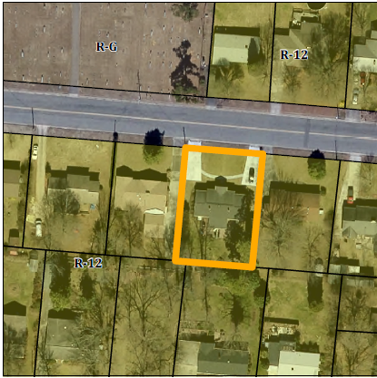
This site was originally developed in 1956, as a duplex. This occurred before the adoption of a Special Uses clause requirement for duplex residences in our ordinance. However, given the residence has been made through ordinance changes a nonconforming use, compliance in the form of a Special Use Permit is now required by the Development Ordinance.

Conformity to The Graham 2035 Comprehensive Plan (GCP) and Other Adopted Plans
Planning Type: Neighborhood
Planning Type
Neighborhood
Development Type
Downtown Residential
For single family residential, new neighborhoods may include duplexes
Include sidewalks, tree coverage, small and medium-sized lots, a variety of housing choices, and porches and stoops that facilitate social interaction.
In street parking, sidewalks on both sides of the street and street trees.
Density of 3 to 6 DU/acre
Development Type: Downtown Residential
Applicable Policies;
- 5.1.1 Housing Variety. Encourage a mix of housing types within Graham to increase choice. These can include single family dwelling units, multi family dwelling units, small units, prefabricated homes, cohousing, and clustered housing. The amendment will provide a duplex constructed prior to the adoption of a graduated residential district by the City of Graham. In 1950, a zoning map was adopted but only separated residential, business, and industrial uses. At this time, multiple family housing was approved on all residential lots.
- 4.3.1 Land Use Patterns. Promote development of efficient land use patterns to allow continued quality and efficiency of water systems. Discourage the extension of water service into areas that are not most suitable for development. The site would use existing city infrastructure, and would allow for continued usage of two dwellings.

DRAFT Findings of Fact and Conclusions
In granting a special use permit, the City Council shall find that all of the six conditions listed below have been met, or it shall be denied. Staff has prepared the following DRAFT findings of fact for each of the six conditions. These findings should be modified by the Council as it considers its decision.
1. All applicable regulations of the zoning district in which the use is proposed are complied with.
- The property is zoned R-12, a duplex is permitted only with a rezoning (R-7) and a special use permit, or a rezoning to R-MF or R-G.
2. Conditions specific to each use, identified by the Development Ordinance, are complied with.
- There are no conditions specific to “dwelling, duplex.”
3. The use will not materially endanger the public health or safety if located where proposed and developed according to the plan as submitted.
- The continued use of the location as a duplex will not materially endanger the public health or safety.
4. The use will not substantially injure the value of adjoining property or that the use is a public necessity.
- The continued use of the location of a duplex will not substantially injure the value of adjoining property.
5. The location and character of the use if developed according to the plan as submitted will be in harmony with the area in which it is to be located and in general conformity with the plan of development for the Graham planning area.
- The duplex is located in a neighborhood residential section of Graham, and is in general conformity with The Graham 2035 Comprehensive Plan.
6. Satisfactory provision has been made for the following, when applicable: vehicle circulation, parking and loading, service entrances and areas, screening, utilities, signs and lighting, and open space.
- All said items have been functioning satisfactorily for the 60 years that the lot has been functioning as a duplex.
Staff Recommendation
Based on The Graham 2035 Comprehensive Plan and the City of Graham Development Ordinance, staff recommends approval of the Special Use Permit. The following supports this recommendation:
- The development furthers goals of The Graham 2035 Comprehensive Plan and is in conformance with the Downtown Residential development type.
- The development meets all six conditions required by Section 10.144 of the Development Ordinance.

