STAFF REPORT
Prepared by Nathan Page, Planning Director

Lacy Ridge (S1601)
Type of Request: Major Subdivision
Meeting Dates
Planning Board on August 16, 2016
City Council on September 6, 2016
Contact Information
Chris Foust
1851 S Main Street, Graham, NC 27253
336-516-1888; kfoust@mcphersongrading.com

Summary
This is a request to create a new major subdivision on the subject properties for 12 lots. The property currently has a dilapidated single family dwelling upon it, as well as an abandoned trailer.
Location
Lacy Holt Rd and
Knightdale Dr
GPIN: 8872499679, 8812590389
Current Zoning
High Density Residential (R-9) and
Low Density Residential (R-18)
Overlay District
none
Surrounding Zoning
R-18, R-12
Surrounding Land Uses
Single family
Size
17.6 acres
Public Water & Sewer
Available along Lacy Holt Rd
Floodplain
No
Staff Recommendation
Approval
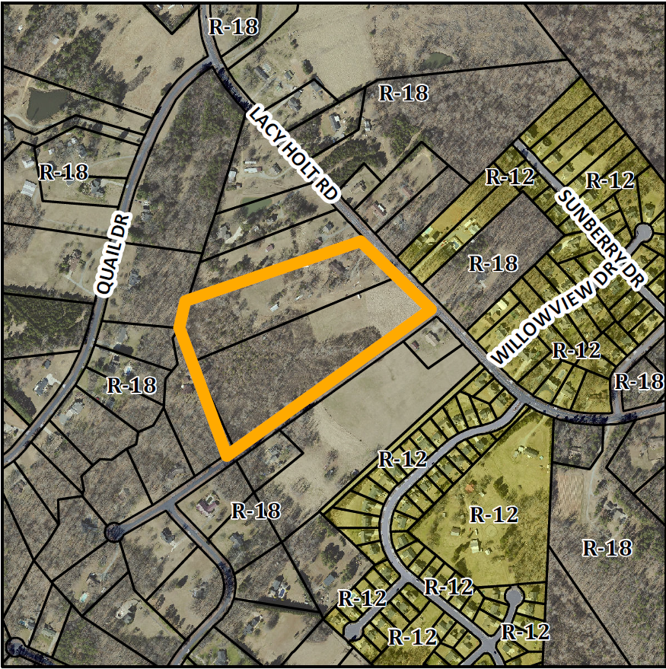
Technical Review Committee
The Technical Review Committee reviewed the application and provided comments to the applicant via the Planning Department. As of the publishing of this agenda packet, the applicant had not responded to the comments. There are substantial required revisions to the plans, but they do not affect the number of proposed lots, nor the access points from Lacy Holt Rd and Knightdale Dr.
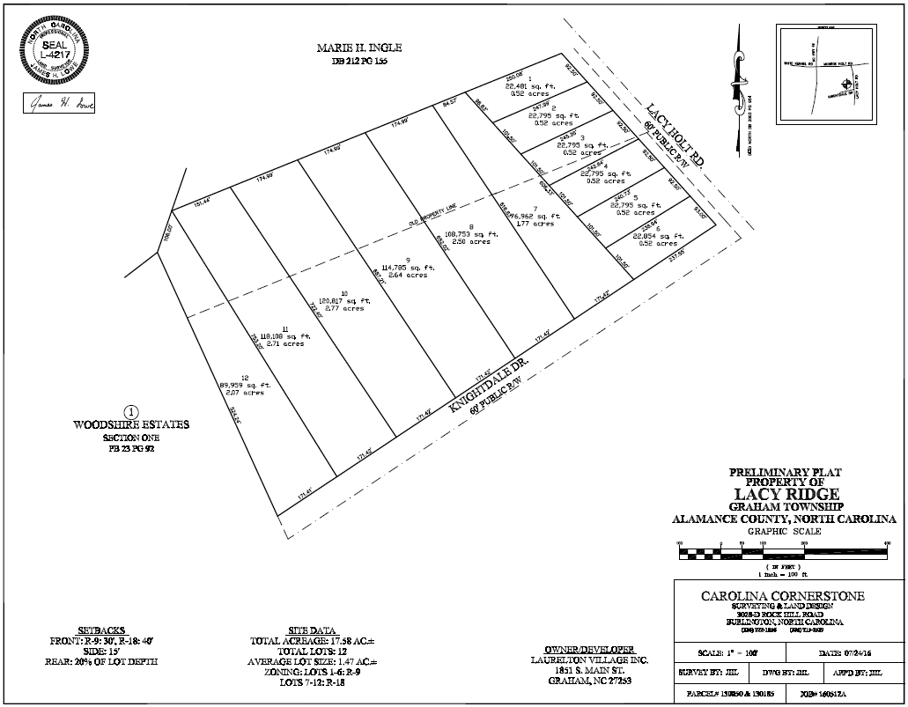
Conformity to the Graham 2035 Comprehensive Plan (GCP) and Other Adopted Plans
Planning Type
Neighborhood
Development Type
Suburban Residential
For single family residential, townhouses, duplexes, accessory dwelling units, and small scale multi-family dwelling of twelve units or less.
Buildings should be located near the front of the property line, oriented towards the street, and include front porches and other private outdoor spaces.
Recess garages behind the front of buildings to avoid streetscapes dominated by garage doors.
Density of 3 to 6 DU/acre
Applicable Policies;
- 5.1.1 Housing Variety. Encourage a mix of housing types within Graham to increase choice. These can include single family dwelling units, multi family dwelling units, small units, prefabricated homes, cohousing, and clustered housing. The subdivision will provide additional small lot homes, and some larger lot homes in the southwestern portion of Graham.
- 4.3.1 Land Use Patterns. Promote development of efficient land use patterns to allow continued quality and efficiency of water systems. Discourage the extension of water service into areas that are not most suitable for development. The site would use existing city infrastructure, and is projected to use septic and well for the large rear lots, where the impacts to a stream may be lessened due to the low density.

Staff Recommendation
Based on The Graham 2035 Comprehensive Plan and the City of Graham Development Ordinance, staff recommends approval of the subdivision. The following supports this recommendation:
- Approving the subdivision would further the policies and strategies put forth by the Graham 2035 Comprehensive Plan, such as Housing Variety.

