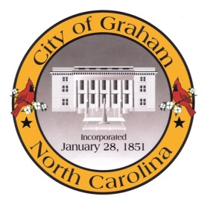

Planning Board

Meeting Agenda
September 20, 2016 at 7:00 PM
Council Chambers, 201 S Main St
Meeting Called to Order, Invocation, and Overview of Board and general meeting rules
1. Approve minutes of the August 16, 2016 meeting
2. New Business
a. RZ1606 Marshall B3. An application by Jason Cook to permit a Financial Office at the location.
3. Old Business
a. Discussion of The Graham 2035 Comprehensive Plan to revisit the plan a year after adoption.

4. Public comment on non-agenda items
Adjourn
A complete agenda packet is available at www.cityofgraham.com

