STAFF REPORT
Prepared by Frank Glover, Planning Intern

Marshall B3 (RZ1606)
Type of Request: Rezoning
Meeting Dates
Planning Board on September 20, 2016
City Council on October 4, 2016
Contact Information
Jason Cook
108 S Maple St, Graham NC 27253
336-516-1889; jcook@stokescook.com

Summary
This is a request to rezone the subject property from R -7 to
B-3. The lot is currently occupied by a single family home. The stated reason for this rezoning request is to permit “a financial office.” This property is located in and around the city’s historic downtown area, and is a part of a compact, connected and diverse neighborhood.
Location
208 S Marshall St
GPIN: 8884233505
Current Zoning
Residential (High Density) R-7
Proposed Zoning
Business (Neighborhood) B-3
Overlay District
none
Surrounding Zoning
O-I, R-7
Surrounding Land Uses
Single Family Homes, Offices
Size
0.5 acres
Public Water & Sewer
Yes
Floodplain
No
Staff Recommendation
Approval
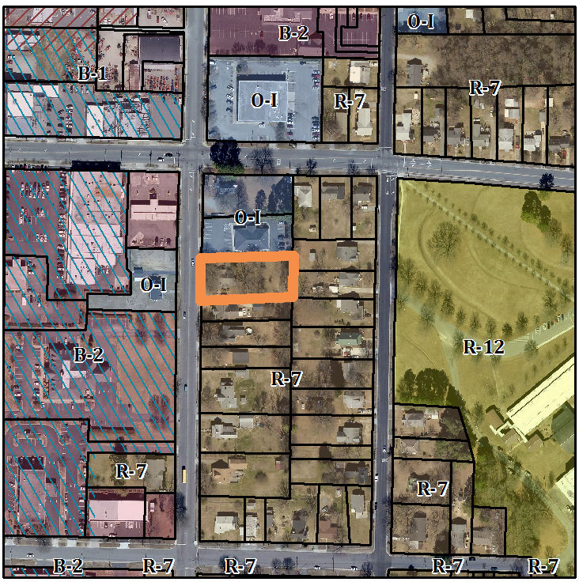

Conformity to the Graham 2035 Comprehensive Plan (GCP) and Other Adopted Plans
Applicable Policies;
Description of Development Type
Downtown Residential
Development Toolkit Checklist
Located near a major thoroughfare
For single family residential
and duplexes
Characteristics include
porches, sidewalks, street trees, and garages setback from the front of the home
Density of 3-6 DU/acre
New homes should consider adjacent lot sizes and building orientations
Supporting Uses: Places of worship, daycares, parks, schools, civic spaces, neighborhood commercial, small professional offices
- 2.3.1 Downtown. A vibrant downtown is critical for Graham’s economic success. Graham’s downtown is a priority when considering incentives, investments, regulations, and marketing. Encourage entertainment options to locate within Graham’s downtown. Increasing the availability of commercial properties may assist in increasing the quantity of individuals frequenting our downtown.
Applicable Strategies;
- 1.1.5 Discourage Strip Development. Discourage strip development along transportation arteries and proposed interstate interchanges by directing these commercial activities to proposed activity centers. A neighborhood business zoning would permit additional low impact commercial uses adjacent to our urban core.

Staff Recommendation
Based on The Graham 2035 Comprehensive Plan, staff recommends approval of the rezoning. The following supports this recommendation:
- Actions like these, done over time, would permit a stronger commercial core with a more gentle transition into the adjacent existing neighborhoods.

