STAFF REPORT
Prepared by Frank Glover, Planning Intern

S Main B2 (RZ1607)
Type of Request: Rezoning
Meeting Dates
Planning Board on January 17, 2017
City Council on February 7, 2017
Contact Information
Jonathan L. Zachary
707 N. Wilba Rd, Mebane NC 27302
919-563-9615; zachary@mebtel.net

Summary
This property is surrounded by two development types; a commercial corridor which fronts on South Main Street, and suburban residential developments which surround the majority of the property. This request is to rezone a portion of the property from R-MF to all B-2. The lot is currently occupied by a farm growing produce and a single family dwelling. The stated reason for this rezoning request is “Only rezoning portion that is R-MF so it will all be the same.” This property is located on a lot whose portion facing 918 S. Main was rezoned from R-12 to B-2 in 2013; the remainder of this lot remaining R-MF. The R-MF portion with access from Ivey Rd and Bullis St is surrounded by properties zoned R-MF and R-12.
Location
918 S Main St
GPIN: 8883283139
Current Zoning
Split Zoned for R-MF
and B-2
Proposed Zoning
General Business B-2
Overlay District
South Main Street/Highway 87 Overlay District
Surrounding Zoning
R-12, R-MF
Surrounding Land Uses
Single Family Homes, Multi-Family Homes, Neighborhood Activity Center
Size
2.265 acres
Public Water & Sewer
Water on Main St and Ivey Rd
Sewer only on Main St
Floodplain
No
Staff Recommendation
Denial

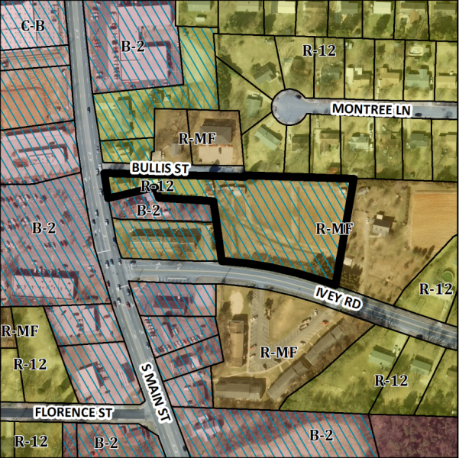
Conformity to the Graham 2035 Comprehensive Plan (GCP) and Other Adopted Plans
Planning District: Suburban Residential

Applicable Policies;
Development Type
Suburban Residential
For single family residential, townhouses, duplexes, accessory dwelling units, and small scale multi-family dwelling of twelve units or less. Buildings should be located near the front of the property line, oriented towards the street, and include front porches and other private outdoor spaces. Recess garages behind the front of buildings to avoid streetscapes dominated by garage doors. Density of 3 to 6 DU/acre

Commercial Corridor
Detached single family housing on small lots less than 6,000 sq ft in area, group homes, and live-work units. 2-5 story building heights, with 0-15 foot front build-to line; No minimum side yard setbacks, 16 foot minimum lot width and 50 foot maximum lot width. Mixed use residential neighborhoods should include diverse housing options. Housing should be built at a human scale, with buildings that reflect Graham’s historic architecture and which create a comfortable space along the street.

- 3.1.2 Safe Access to Businesses and Homes.
Limit direct highway access or the number of curb cuts to commercial activities by directing development to proposed regional and village centers and requiring internal connectivity between commercial uses, uniformity in design standards, and rear alley access where feasible. Increasing the availability of strip commercial properties could work against the adjacent Neighborhood Activity Center, and potentially add traffic impacting the nearby school.
Applicable Strategies;
- 1.1.5 Discourage Strip Development. Discourage strip development along transportation arteries and proposed interstate interchanges by directing these commercial activities to proposed activity centers. A General Business zoning would conflict with the surrounding residential areas which are to the north of a planned Neighborhood Activity Center and the Hwy/87 Overlay district.
- 2.3.1 Facilitate focused development. Incentivize pedestrian-oriented nodal development consistent with this plan by incentivizing smart growth development. Rezoning this property lot to B-2 would counter the goals of pedestrian-oriented nodal development and smart growth development while encouraging commercial strip developments.

Staff Recommendation
Based on The Graham 2035 Comprehensive Plan, staff recommends denial of the rezoning. The following supports this recommendation:
- Rezoning this portion of the property would not be consistent with the Suburban Residential development type. Leaving this property as its current zoning (R-MF) would provide a buffer between commercial and single family development.

