STAFF REPORT
Prepared by Nathan Page, Planning Director

Longdale Residential (RZ1608)
Type of Request: Rezoning
Meeting Dates
Planning Board on January 17, 2017
City Council on February 7, 2017
Contact Information
Joe Sizemore
5648 Mt Hermon Rock Creek Rd
Snow Camp NC, 27349
919-260-9138; jlsizemorre@bellsouth.net

Summary
This is a request to rezone the subject property from R-12 and R-18 to R-9. The property is currently vacant and wooded. The Graham 2035 Comprehensive Plan recommends the western portion of the lot be Mixed Use Residential, with the remainder of the lot being Suburban Residential.
Location
Longdale Dr
GPIN: 8894032541
Current Zoning
Residential, low density
(R-18) and Residential, medium density (R-12)
Proposed Zoning
Residential, high density (R-9)
Overlay District
none
Surrounding Zoning
R-18, R-12
Surrounding Land Uses
Single Family and Vacant
Size
34.8 acres
Public Water & Sewer
Yes
Floodplain
No
Staff Recommendation
Approval

While the Plan suggests that portions of this area be considered for Mixed Use Residential, the lack of road connectivity raises access concerns for this area, and staff therefore recommends a rezoning in line with the less dense suburban residential.
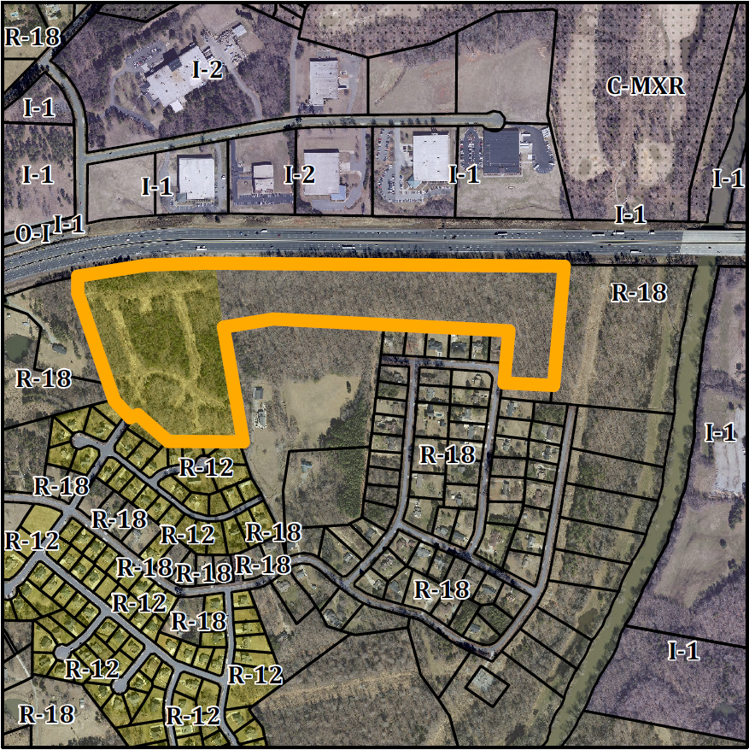

Conformity to the Graham 2035 Comprehensive Plan (GCP) and Other Adopted Plans
Planning Type
Neighborhood
Development Type
Mixed Use Residential
Detached single family housing on small lots less than 6,000 sq ft in area, group homes, and live-work units.

2-5 story building heights, with 0-15 foot front build-to line; No minimum side yard setbacks, 16 foot minimum lot width and 50 foot maximum lot width.

Mixed use residential neighborhoods should include diverse housing options. Housing should be built at a human scale, with buildings that reflect Graham’s historic architecture and which create a comfortable space along the street.

Suburban Residential
For single family residential, townhouses, duplexes, accessory dwelling units, and small scale multi-family dwelling of twelve units or less.
Buildings should be located near the front of the property line, oriented towards the street, and include front porches and other private outdoor spaces.
Recess garages behind the front of buildings to avoid streetscapes dominated by garage doors.
Density of 3 to 6 DU/acre
Applicable Policies;
- 3.3.2 Focused Development. In order to maintain Graham’s affordability and promote growth, the city will facilitate smart growth development by promoting infill development and focused, walkable, and mixed use built environments. This development utilizes the land which is served by city water and sewer more efficiently than maintaining the existing lower density zoning. Additionally, the Suburban Residential neighborhood type density recommendations are greater than that which is permitted by R-18 zoning.
Applicable Strategies;
- 4.3.1 Land Use Patterns. Promote development of efficient land use patterns to allow continued quality and efficiency of water systems. Discourage the extension of water service into areas that are not most suitable for development. The site would use existing city infrastructure.

Staff Recommendation
Based on the Graham 2035 Comprehensive Plan and the City of Graham Development Ordinance, staff recommends approval of the rezoning. The following supports this recommendation:
- Rezoning the property is consistent with the Suburban Residential type and furthers the policies and strategies put forth by the Graham 2035 Comprehensive Plan, such as connected, efficient development.

