STAFF REPORT
Prepared by Nathan Page, Planning Director

Mallard Care Home (SUP1701)
Type of Request: Special Use Permit
Meeting Dates
Planning Board on March 21, 2017
City Council on April 4, 2017
Contact Information
Garry Wiley
839 Wilkesboro Blvd. Hickory, NC 28645
336-340-8752
gwiley@umhs.net

Summary
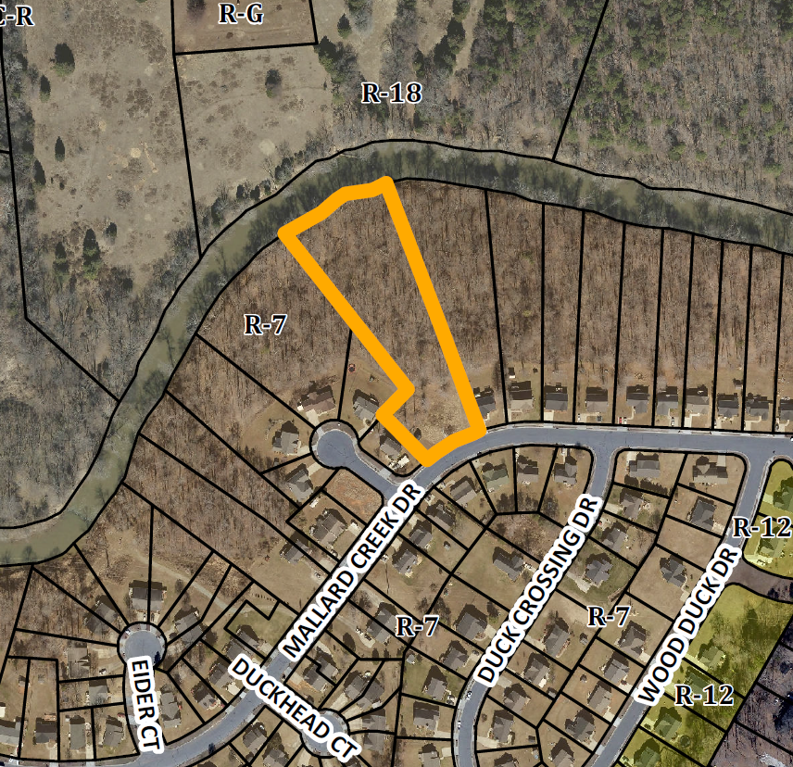
This is a request for a Special Use Permit for a Family Care Home for property located at 304 Mallard Creek Drive. There is an existing single family dwelling on the site.
Location
304 Mallard Creek Dr
GPIN: 8882488202

Current Zoning
Residential (high density)
(R-7)
Proposed Zoning
n/a
Overlay District
none
Surrounding Zoning
R-7, R-18
Surrounding Land Uses
Single Family, and Vacant
Size
2.17 acres
Public Water & Sewer
Yes
Floodplain
Yes
Staff Recommendation
Approval

Under the current Development Ordinance, a Family Care Home is a facility that provides room and board to between 2 to 6 residents with disabilities in a family environment. Granting this Special Use Permit would permit up to 6 unrelated individuals to reside within the unit.

Conformity to The Graham 2035 Comprehensive Plan (GCP) and Other Adopted Plans
Planning Type: Neighborhood
Planning Type
Neighborhood
Development Type
Suburban Residential
For single family residential, new neighborhoods may include duplexes
Include sidewalks, tree coverage, small and medium-sized lots, a variety of housing choices.
Density of 3 to 6 DU/acre
Development Type: Suburban Residential
Applicable Policies;
- 5.1.1 Housing Variety. Encourage a mix of housing types within Graham to increase choice. These can include single family dwelling units, multi family dwelling units, small units, prefabricated homes, cohousing, and clustered housing. The Special Use Permit will allow a house which meets the requirements of a Family Care Home to service more than one individual.
- 4.3.1 Land Use Patterns. Promote development of efficient land use patterns to allow continued quality and efficiency of water systems. Discourage the extension of water service into areas that are not most suitable for development. The site would use existing city infrastructure.

DRAFT Findings of Fact and Conclusions
In granting a special use permit, the City Council shall find that all of the six conditions listed below have been met, or it shall be denied. Staff has prepared the following DRAFT findings of fact for each of the six conditions. These findings should be modified by the Council as it considers its decision.
1. All applicable regulations of the zoning district in which the use is proposed are complied with.
- The property is zoned R-7, and a Family Care Home is permitted with a Special Use Permit in R-7.
2. Conditions specific to each use, identified by the Development Ordinance, are complied with.
- There is a single condition; that it be further than ½ mile from existing Family Care Homes. There are no permitted Family Care Homes within a ½ mile of the location.
3. The use will not materially endanger the public health or safety if located where proposed and developed according to the plan as submitted.
- The use of the location as a Family Care Home will not materially endanger the public health or safety.
4. The use will not substantially injure the value of adjoining property or that the use is a public necessity.
- The use of the location as a Family Care Home will not substantially injure the value of adjoining property.
5. The location and character of the use if developed according to the plan as submitted will be in harmony with the area in which it is to be located and in general conformity with the plan of development for the Graham planning area.
- The proposed Family Care Home is located in a neighborhood residential section of Graham, and is in general conformity with The Graham 2035 Comprehensive Plan.
6. Satisfactory provision has been made for the following, when applicable: vehicle circulation, parking and loading, service entrances and areas, screening, utilities, signs and lighting, and open space.
- All said items are equal to or in excess of the NC Building Code for single family dwellings.
Staff Recommendation
Based on The Graham 2035 Comprehensive Plan and the City of Graham Development Ordinance, staff recommends approval of the Special Use Permit. The following supports this recommendation:
- The development furthers goals of The Graham 2035 Comprehensive Plan and is in conformance with the Suburban Residential development type.
- The development meets all six conditions required by Section 10.144 of the Development Ordinance.

