STAFF REPORT
Prepared by Nathan Page, City Planner

Steve’s Setbacks (CR1701)
Type of Request: Conditional Rezoning
Meeting Dates
Planning Board on March 21, 2017
City Council on April 4, 2017
Contact Information
Justin Long
912 Rumar St, Graham NC 27253
919-606-8668

Summary
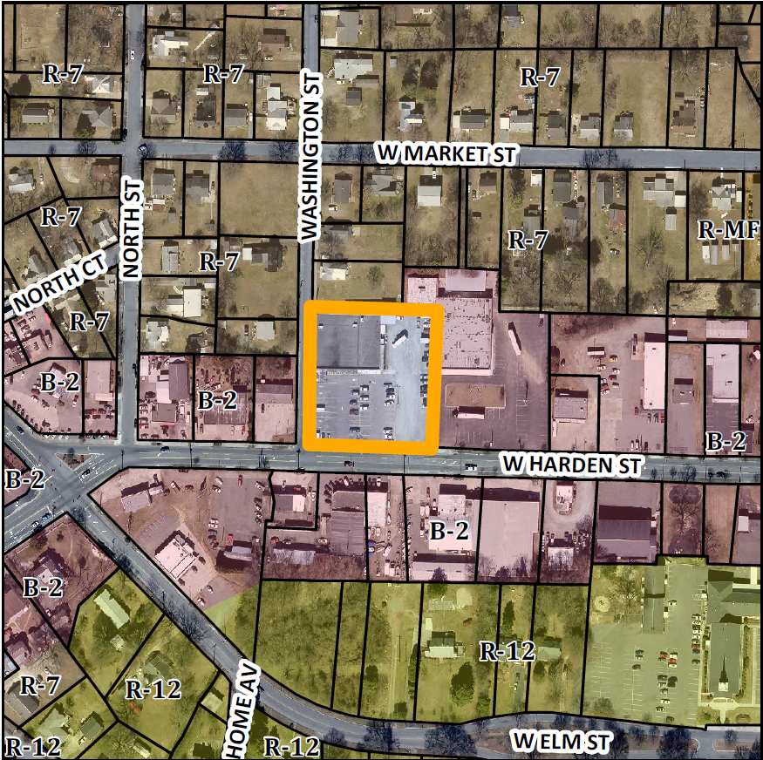
This is a request to rezone the subject property from I-1 to C-B. The applicant is proposing to “allow for further expansion to take place closer to the property line and not interfere with the parking lot.” The proposed uses for the new zone would include all uses within General Business (B-2), and the rear and side yards would be reduced to zero. The front yard thirty foot setback will be maintained (reduced from the current fifty foot front yard). The property is currently functioning as a grocery store as well as a religious service building.
Project Name
Steve’s Setbacks (CR1701)
Location
329, 331 W Harden St
GPIN: 8874955048
Size
1.32 acres
Proposed Density
N/A
Current Zoning
Industrial (light)
(I-1)
Proposed Zoning
Conditional Business (C-B)
Surrounding Zoning
B-2, R-7
Surrounding Land Uses
Single Family, Commercial
Staff Recommendation
Approval, with conditions

The applicant is proposing to rezone the property to C-B in order to permit expansion within land typically reserved for setbacks. In particular, the Side Yard Abutting Street (currently, 50 feet), and the Rear Yard (currently, 50 feet). The building was constructed in 1956, and a copy of the zoning restrictions from 1957 indicate that for business or industrial uses next to residential lots an 8 foot yard was required.
Conformity to The Graham 2035 Comprehensive Plan (GCP) and Other Adopted Plans
Development Type: Mixed Use Commercial
Description of Development Type
Mixed Use Commercial
Buildings located no further than 15 feet from the front lot line
3-5 story building heights
Sidewalks, small block lengths, on-street parking, transparent windows on >50% of front façade
A mix of uses is desirable, including retail, commercial, office, multifamily residential, and institutional uses
Built to a human scale

- Orient buildings toward plazas, parks, and streets
- Minimize building setbacks from public streets
- Encourage parking in the rear of commercial and residential buildings While the Plan calls for a fifteen foot front yard build-to line, the probability of a widening for West Harden Street in the future suggests maintaining the thirty foot front yard requirement within the Development Ordinance (40 feet reduced by 10 feet due to the proximity of the adjacent items).
Applicable Policies and Recommendations
- 2.1.5 Reduce Barriers Work with local businesses and economic development partners to identify and address unnecessary barriers to local business development. While the street yard setbacks, and the setbacks adjacent to residences protect the value and public safety, this structure was constructed before the current regulations were put into place. It would remove a barrier to expansion to grant the Conditional Zoning.
- 2.2.1 Focused Development In order to maintain Graham’s affordability and promote growth, the City will facilitate smart growth development by promoting infill development and focused, walkable, and mixed use built environments. While it is unlikely this parcel will develop into residences, it currently serves both as a religious institution as well as a retail space located within walking distance of the downtown core. Taken together, the development should be incentivized within the structure of the Ordinance.
- 2.3.1 Facilitate Focused Development Incentivize pedestrian-oriented nodal development consistent with this plan by incentivizing smart growth development. The City could choose to utilize some of the following methods; Expedited permit review, Deferred tax payments, Covering some building expenses, Low-interest loans, Providing infrastructure, Flexible and innovative regulations, Small area plans. The granting of approval for this rezoning would be an example of flexible and innovative regulations and potentially positively affect future development.
- 2.4.2 Promote Industrial Redevelopment Encourage reinvestment and intensification at existing industrial sites. Encourage redevelopment of existing builds and infrastructure for industrial growth. While this site is zoned industrial, it has been used as a grocery store for decades. The rezoning would also be more in line with the adjacent parcels, which are all B-2 or R-7. The rezoning would also allow for future redevelopment.

Staff Recommendation
Based on The Graham 2035 Comprehensive Plan and the City of Graham Development Ordinance, staff recommends approval of the conditional rezoning.
The following supports this recommendation:
Permitting this conditional zoning will create a conforming structure and allow for future expansion of a successful local business.

