STAFF REPORT
Prepared by Frank Glover, Planning Intern

Riverwalk Sign (CR1702)
Type of Request: Conditional Rezoning
Meeting Dates
Planning Board on May 16, 2017
City Council on June 6, 2017
Contact Information
Harendra J. Patel
1202 Raspberry Run, Graham NC 27253
336-226-9400

Summary
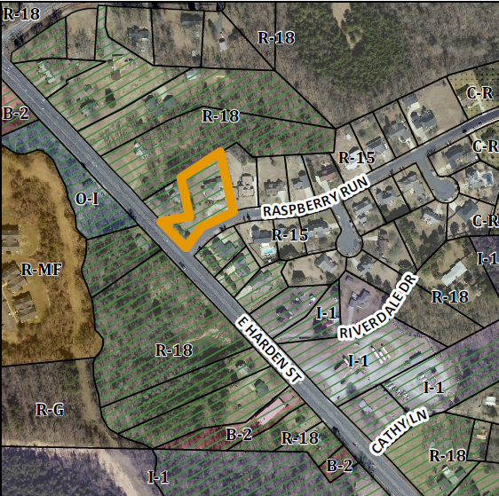
This is a request to rezone the subject property from R- 15 to C-R. The property is within the Harden Street Overlay. The applicant is proposing to “allow for a single sign being located inside (east) of the common property line and the Harden Street/Hwy 54 right-of-way.” The proposed Conditional Rezoning would not change the existing single family residence on the said property. The property is currently functioning only as a single family residence.
Project Name
Riverwalk Sign (CR1702)
Location
1202 Raspberry Run
GPIN: 8883991689
Size
0.94 acres
Proposed Density
N/A
Current Zoning
Low Density Residential (R-15) Within HWY-54 OD
Proposed Zoning
Conditional Residential (C-R)
Surrounding Zoning
R-18, R-15
Surrounding Land Uses
Single Family
Staff Recommendation
Denial

Conformity to The Graham 2035 Comprehensive Plan (GCP) and Other Adopted Plans
Development Type: Highway Commercial
Description of Development Type
Highway Commercial
Appropriate Density
6 dwelling units per acre
0.4 Commercial/Industrial FAR
Desired Pattern
Focused in strategically located clusters identified within the plan. Where commercial growth occurs along the NC 54 corridor, pedestrian, bicycle, and vehicular safety should be promoted through high quality planned development.

Applicable Policies and Recommendations
- 1.1.2: Design Guidelines Develop commercial and residential site design guidelines that enhance community character and appearance, to be used with special use permit and conditional rezoning applications. Because this property lot is in a medium to low density zoning district every effort should be made to maintain its character. The city should carefully consider off-site signs to prevent a trend.
- 1.3.3: East Harden Prepare a corridor plan to guide development and public investment in the East Harden/NC 54 Corridor. While the property in question lies within this corridor district it’s also currently zoned residentially.
- 2.3.1 Facilitate Focused Development Incentivize pedestrian-oriented nodal development consistent with this plan by incentivizing smart growth development. The City could choose to utilize some of the following methods; Expedited permit review, Deferred tax payments, Covering some building expenses, Low-interest loans, Providing infrastructure, Flexible and innovative regulations, Small area plans. The granting of approval for this conditional rezoning would be an example of flexible and innovative regulations and potentially positively affect future development.

Staff Recommendation
Based on The Graham 2035 Comprehensive Plan and the City of Graham Development Ordinance, staff recommends denial of this conditional rezoning.
As content regulation of signage is illegal, the City would have no means of preventing a subsequent proliferation of outdoor advertising.

