STAFF REPORT
Prepared by Nathan Page, Planning Director

Disash Business (RZ1701)
Type of Request: Rezoning
Meeting Dates
Planning Board on May 16, 2017
City Council on June 6, 2017
Contact Information
Frank Longest
3453 Forestdale Drive, Burlington NC 27215
336-227-7461, flongest@hlwbmlaw.com

Summary
This property is surrounded by two development types; a large multi-family tract, and suburban residential across Harden Street. This request is to rezone a portion of the property from R-MF to all B-2. The lot is currently occupied by a duplex. The stated reason for this rezoning request is to “…permit use of the property for any use permitted by right in a B-2 zone.” There is concern for how this property will be served by sewer.
Location
602 E Harden St
GPIN: 8884537331
Current Zoning
Multifamily Residential R-MF
Proposed Zoning
General Business B-2
Overlay District
East Harden St Highway 54 Overlay District
Surrounding Zoning
R-12, R-MF
Surrounding Land Uses
Single Family Homes,
Multi-Family Homes
Size
2.44 acres

Public Water & Sewer
Water on Harden St
Sewer only on Gunter St
Floodplain
No
Staff Recommendation
Approval
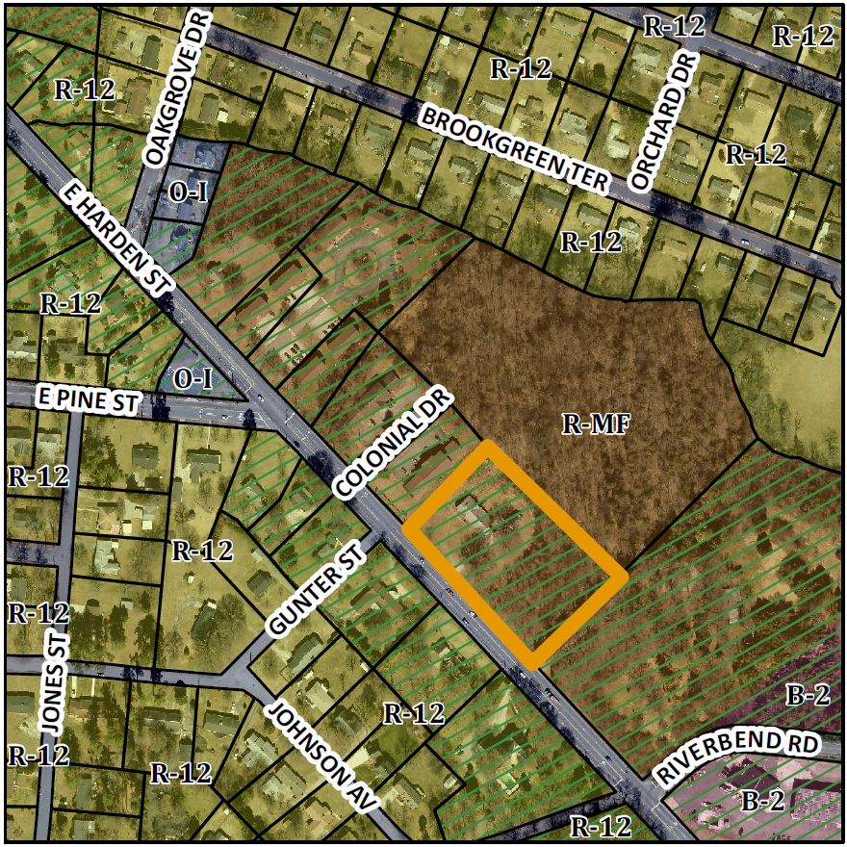

Conformity to the Graham 2035 Comprehensive Plan (GCP) and Other Adopted Plans
Planning District: Mixed Use Commercial

Applicable Policies;
Development Type
Mixed Use Commercial
Buildings located no further than 15 feet from the front lot line
3-5 story building heights
Sidewalks, small block lengths, on-street parking, transparent windows on >50% of front façade
A mix of uses is desirable, including retail, commercial, office, multifamily residential, and institutional uses
Built to a human scale

- 3.1.2 Safe Access to Businesses and Homes.
Limit direct highway access or the number of curb cuts to commercial activities by directing development to proposed regional and village centers and requiring internal connectivity between commercial uses, uniformity in design standards, and rear alley access where feasible. This property is an identified regional center, and the rezoning would allow for a land use which could support the proposed and existing multifamily homes.
Applicable Strategies;
- 1.1.5 Discourage Strip Development. Discourage strip development along transportation arteries and proposed interstate interchanges by directing these commercial activities to proposed activity centers. This parcel is in the vicinity of an Interchange Regional Node, on a high volume traffic route. The proposed residential density in the vicinity also lends itself to additional retail and service industries.
- 2.3.1 Facilitate focused development. Incentivize pedestrian-oriented nodal development consistent with this plan by incentivizing smart growth development. Rezoning this property lot to B-2 would reinforce the goals of pedestrian-oriented nodal development and smart growth development while discouraging commercial strip developments.

Staff Recommendation
Based on The Graham 2035 Comprehensive Plan, staff recommends approval of the rezoning. The following supports this recommendation:
- The adjacent multifamily developments, the quantity of vehicle traffic, and the size of the Highway 54 corridor suggest that a business may be better suited to this site than additional apartments.

