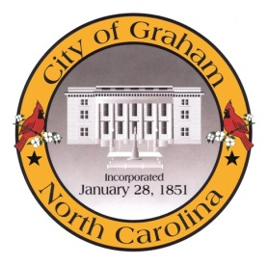

Planning Board

Meeting Agenda
July 18, 2017 at 7:00 PM
Council Chambers, 201 S Main St
Meeting Called to Order, Invocation, and Overview of Board and general meeting rules
1. Approve minutes of the June 20, 2017 meeting
2. New Business
a. AM1705 Subdivision Exemptions. Updating the definition of a subdivision as required by the North Carolina General Assembly.
b. AM1706 Floodplain Regulations. Updating the article and adopting new maps as required by the Federal Emergency Management Agency.
3. Old Business
a. Comprehensive Plan Update. Discussion regarding ideas and procedure for subsequent meetings.
4. Public comment on non-agenda items
Adjourn
A complete agenda packet is available at www.cityofgraham.com

