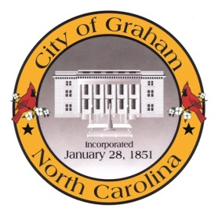

Planning Board

Meeting Agenda
October 17, 2017 at 7:00 PM
Council Chambers, 201 S Main St
Meeting Called to Order, Invocation, and Overview of Board and general meeting rules
1. Approve minutes of the August 15, 2017 meeting
2. New Business
c. AM1708 Overlay Access. Request from the Planning Board to address cross-access agreements for commercial development within the Overlay Districts.
3. Old Business
a. Comprehensive Plan Update. Discussion regarding ideas. Potentially making a recommendation to City Council.
4. Public comment on non-agenda items
Adjourn
A complete agenda packet is available at www.cityofgraham.com

