|  |  |  |
| --- | --- | --- |
| **MAR 22, 2020** | **through** | **MAR 28, 2021** |

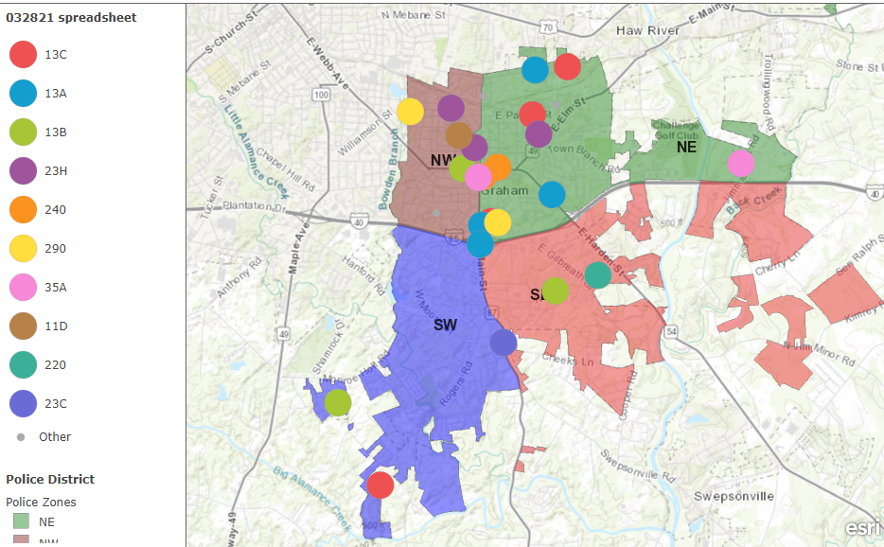



|  |  |  |
| --- | --- | --- |
| **INCIDENT DATE/TIME** | **NIBRS** | **NIBRS DESCRIPTION** |

