**City of Graham City Council**

**Regular Meeting Agenda**

**October 11, 2022**

**6:00 p.m.**

**CALL TO ORDER:** Mayor Jennifer Talley

**INVOCATION & PLEDGE OF ALLEGIANCE**

**STAFF REPORTS:** Historic Museum Commission Façade Projects Update

**CONSENT AGENDA:**

1. To approve September 13, 2022, City Council meeting minutes and the September 27, 2022, special meeting minutes.
2. To authorize the City Manager and City Attorney to execute the scope of services with Piedmont Triad Regional Council to update the 2035 Comprehensive Plan in the amount of $40,000, and to approve the associated budget amendment.
3. To approve a contract amendment with Alley, Williams, Carmen & King to provide dedicated office hours for city-related engineering services.
4. To approve closing streets for Graham High School’s Homecoming Parade on October 21, 2022, from 4:45 pm to 5:30 pm. The procession will begin at Albright Avenue, down Main Street, around Court Square, down Pine Street, and ending at Graham Middle School.
5. To approve a request from Alamance County Veterans Organization for the City of Graham to provide public safety during the Veterans Day Festival/Parade on November 12, 2022, from 9:00 am to 11:30 am.
6. To approve a request by ALCOVETS to close East Elm Street from 10:00 am to 7:00 pm to honor veterans.
7. To approve the following tax releases in the amount of $2,086.59.

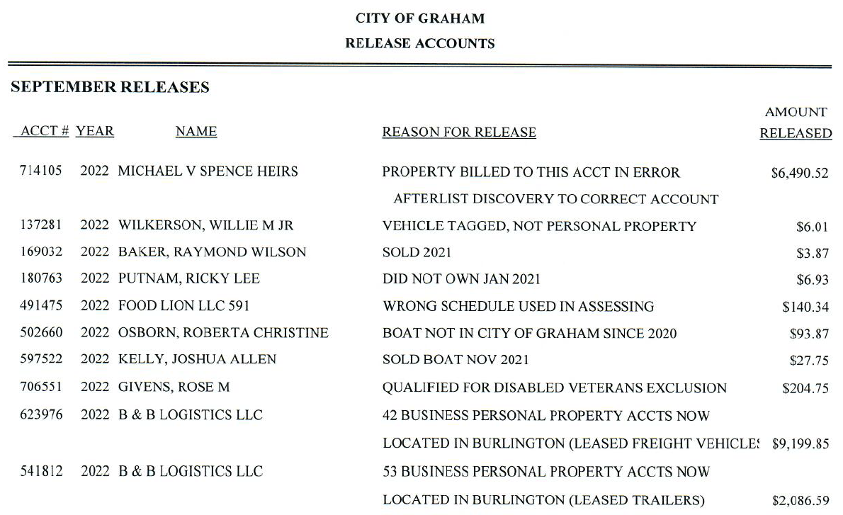

**Public Hearings:**

* + - 1. **REZONING: 0.25 ARES - 300 E ELM STREET**

City Council will consider rezoning 0.25 acres of property from R-7, High-Density Residential, to C-B, Conditional Business for the purpose of utilizing the existing home structure as a hair salon.

*(Planning Board recommended approval)*

* + - 1. **RECLASSIFICATION: 0 East harden street**

City Council will consider reclassifying a portion of property located on 0 East Harden Street from CB, Conditional Business, to R-7, High-Density Residential, to allow the property owner to utilize the full extent of the lot. *(Planning Board recommended approval)*

**old business:**

* + - 1. **HISTORIC RESOURCES COMMISSION – FAÇADE GRANT PROGRAM**

City Council will consider approving a budget amendment in the amount of $10,583.00, for the Historic Resources Commission façade grant program.

**NEW BUSINESS:**

* + - 1. **ORDINANCE AMENDMENT – CHAPTER 12, ARTICLE 3 – HEIGHT OF GRASS:**

City Council will consider an amendment to Chapter 12, Article 3, to reduce the allowable height of grass, weeds, and noxious vegetation from 18 inches to 12 inches.

* + - 1. **ARPA FUND REQUEST – RECREATION – BOAT RAMP RENOVATIONS:**

City Council will consider ARPA funds in the amount of $195,000.00, for the Graham-Mebane Lake boat ramps renovation project.

**PUBLIC COMMENT PERIOD**

**CITY STAFF COMMENTS**

**City Council Comments**

**ADJOURN**